
11

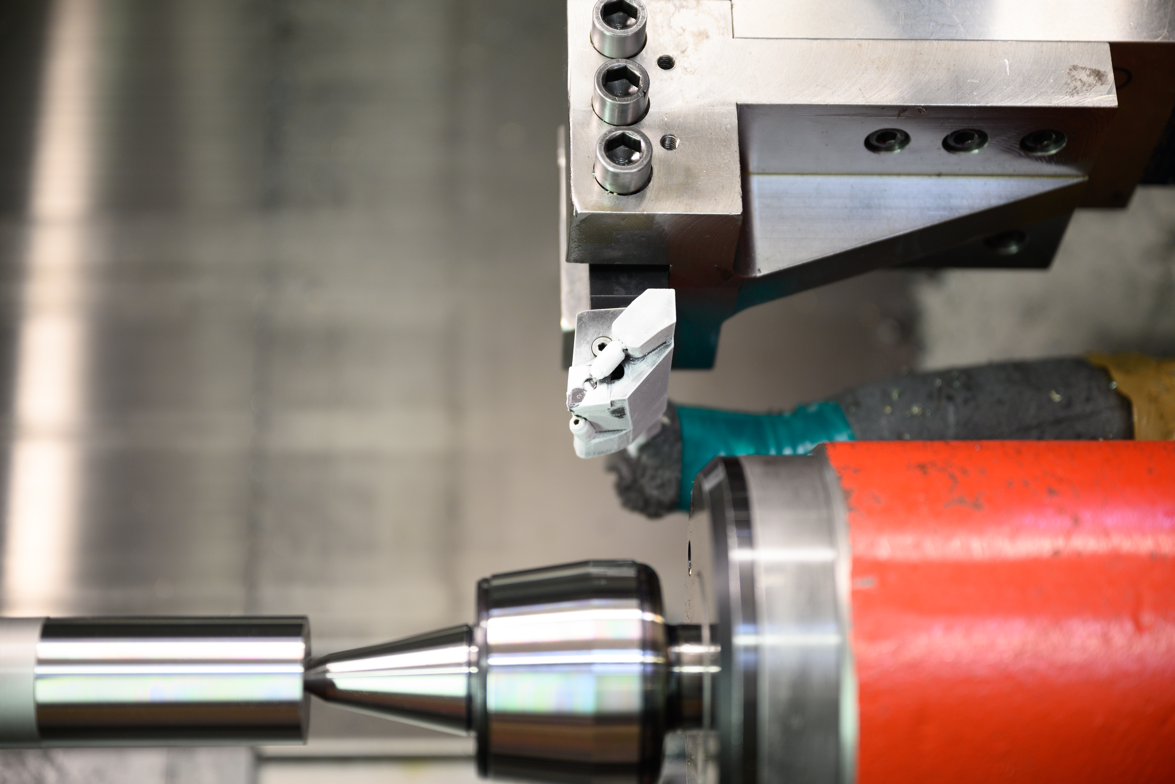

Effect of CRYO-MQL
on the surface integrity characteristics of machined Vanadis8 tool steel.
Master’s thesis in Production Engineering

BHARATH REDDY MANDARA

DEPARTMENT OF INDUSTRIAL AND MATERIALS SCIENCE
CHALMERS UNIVERSITY OF TECHNOLOGY
Gothenburg, Sweden 2023
www.chalmers.se

Effect of CRYO-MQL on the surface integrity characteristics of machined Vanadis8 tool steel.
Bharath Reddy Mandara

©BHARATH REDDY MANDARA, 2023

Supervisor and Examiner: Peter Krajnik, Professor, Division of Materials and Manufacturing, Department of Industrial and Materials Science.

Master’s Thesis 2023:NN
Department of Industrial and Material Science
Division of Materials and Manufacturing
Chalmers University of Technology
SE-412 96 Göteborg
Sweden
Telephone: + 46 (0)31-772 1000

Cover:
Effect of CRYO-MQL on the surface integrity characteristics of machined Vanadis8 tool steel.

Department of Industrial and Materials Science
Göteborg, Sweden, 2023

Abstract
The machining industry is on the verge of transitioning from conventional to more sustainable practices. Different techniques of lubrication are one area of research that is evidently developing new practices to incorporate less waste while improving the tool life and performance of the workpiece. This research study compares surface integrity characteristics by machining the workpieces with alternative lubrication techniques, i.e., dry, emulsion, and minimum quantity lubrication. Residual stresses are measured by X-ray diffraction, and surface roughness is measured by optical profilometry to identify surface integrity parameters of the machined work pieces. This study expands the application of minimum quantity lubrication (MQL) by replacing the currently used aerosol mixture with cryogenic liquid nitrogen (CRYO) to reduce the heat generated at the cutting edge of the tool during the machining process.
An experimental setup was utilised to conduct the necessary analysis for this research study. A new MQL setup was used to replace aerosol with liquid nitrogen. To analyse residual stress, the workpieces were etched to generate depth profiles, enabling the measure of the residual stress on the surface and underneath the top surface. Further, the same workpieces were used to measure the surface roughness in an optical profilometer.
The temperature of the Cryogenic atmosphere at the tool and the cutting speeds were optimized by a test matrix, and these parameters were utilized throughout this research. The optimal cutting speeds (Vc) used were 50, 100, and 150 m/min, with a constant feed rate (f) of 0.15 mm/rev and the depth of cut (Ap) was 0.15 mm.
Vanadis8 was the raw material, which was further heat-treated and used as the workpiece material. Turning operations were performed on the workpiece with varied lubrication techniques. The dynamometers were mounted on the tool holders during turning operations to measure the feed, cutting, and passive forces.
The experiments were repeated for the second time to validate the residual stress and surface roughness measurements on the workpieces with the same parameters and experimental setup.
The findings from residual stress and surface roughness measurements based on the cutting parameters with dry, emulsion and CRYO-MQL techniques are discussed in this research project.

Keywords: Tool steel, residual stresses, surface roughness, surface integrity, lubricating method during machining.

Acknowledgements

I am fortunate to have the reference of my late father, Mr J.C. Reddy’s background in the manufacturing industry for 55 years, which has inspired me to follow his footsteps and look forward to contributing further towards developing sustainable and innovative manufacturing techniques.

I would like to thank Peter Krajnik for the opportunity to execute my master’s thesis at the Division of Materials and Manufacturing, Department of Industrial and Materials Science. It allowed me to learn about different techniques and instruments, enhancing my knowledge and its importance for implementing these learnings in the manufacturing industry. I would also like to thank all the people at The Centre for Metal Cutting Research for their contributions to this diploma work and the warm welcome.

I am very grateful for the opportunity to work alongside Dinesh Mallipedi, and I thank him for his guidance during the project and his continued support beyond my academics.

A sincere appreciation towards the Industrial and Material Science department and faculties for their contributions to this diploma work and the warm welcome.

Finally, I sincerely thank my family and friends for their constant support and advice.

Contents
Contents 3
1 Introduction 6
1.1 Selection of lubrication method 6
1.2 Project scope 6
1.3 Research question 7
2 Background and Theory 8
2.1 Workpiece 8
2.1.1 Steel 8
2.1.2 Tool steel 8
2.1.3 Hardening of Vanadis 8 9
2.2 Machining process 10
2.2.1 Turning process 10
2.2.2 Parameters 11
2.2.3 Cutting conditions 12
2.3 Analysis method 16
2.3.1 X-ray diffraction 16
2.3.2 Surface roughness using optical profilometry 18
3 Experimental setup 20
3.1 Workpiece used 20
3.2 Residual forces generation 20
3.3 Tool inserts and holder 21
3.4 Lubricant 21
3.5 Temperature optimisation 22
3.6 Cutting speed optimisation 23
3.7 Sampling nomenclature 23
4 Experimental results and discussion 24
4.1 Residual stresses results 24
4.1.1 Residual stresses during the Dry coolant technique 24
4.1.2 Residual stresses emulsion coolant technique 26
4.1.3 Residual stresses during Cryo MQL (T= -10°C) coolant technique 27
4.1.4 Residual stresses during Cryo MQL (T= -40 °C) coolant technique 28
4.1.5 Stresses induced for unmachined workpieces. 30
4.1.6 Verification of stresses induced results 31
4.2 Surface roughness results 33
5 Conclusion and limitations 36
5.1 Etching for stress measurement and depth profiling 36
5.2 Conclusions from residual stress and surface roughness analysis 36
5.3 Future scope 37
6 References 41

Introduction
Numerous research projects are conducted worldwide with the advancement of machining processes to make them more sustainable and cost-effective. Lubrication techniques are crucial in achieving the desired properties of machined workpieces during the machining process.

As the years progressed, various lubricating techniques, including dry, emulsion, and minimum quantity lubrication, were implemented in the industry. These lubricating techniques are classified by the medium (compressed air, oil, and emulsion) used to apply the lubricant to the machining surface. The achieved surface integrity determines the quality of machined parts. Surface crack density, residual stresses, recast layer thickness, and surface roughness are crucial parameters that can be considered when estimating the surface integrity.

This study aimed to compare the surface integrity parameters, such as residual stresses and surface roughness, achieved on the workpiece by implementing various lubrication techniques.

Selection of lubrication method
The dry lubrication method resulted in inadequate heat dissipation and short tool life during machining, whereas the emulsion-based lubrication method generated excessive waste, lowering the working environment. To counteract this disadvantage, a modern technique of minimum quantity lubrication is proving effective in the current industrial climate.

Although the current MQL techniques utilizing an aerosol mixture effectively reduce waste and the friction between the cutting tool and the workpiece’s interfacial surface, they could be more effective at reducing the total heat generated by the entire machining process. To improve further, the aerosol mixtures are replaced with a cryogenic base, liquid nitrogen at -10 °C, -40 °C, and –60 °C.

Project scope
The study was conducted at the Department of Industrial and Material Science, in Chalmers University of Technology, Göteborg, SWEDEN.

This research is conducted by machining workpieces using a turning operation at various cutting speeds of 50, 100, and 150 m/min with dry, emulsion, and cryogenic MQL as lubrication techniques. Optimized and uniformly applied machining parameters, such as depth of cut and feed rate of 0.15 mm and 0.15 mm/rev, respectively, were applied to all workpieces.

X-ray diffraction and optical profilometry were used to measure surface integrity parameters such as residual stresses and surface roughness for each machined workpiece. Workpieces were etched with precise locations where residual stresses were measured in the cutting and feed directions. To verify the accuracy of the measurements, duplicates of workpieces subjected to the same cutting conditions were created, and the results were compared.

Research question
The final results of this thesis are a comparison of the surface integrity properties for each cutting condition and a determination of the practicability of employing an MQL technique, particularly one employing cryogenic liquid nitrogen as the lubricating method during the machining of hardened tool steel.

Background and Theory
This section discusses the background of the theoretical concepts incorporated into the research study.

Workpiece

Steel
Steel is one of the most commonly used engineering materials in various industries worldwide. The significance of steel in the global market is due to the unique property of being able to be recycled multiple times while retaining its properties.

Steel is an iron alloy fused with less than 1% manganese, 2% carbon, and trace amounts of oxygen, sulphur, phosphorus, and silicon[1]. Steel is classified into four types based on its composition: carbon steel, alloy steel, stainless steel, and tool steel.

Tool steel is best suited for cutting tools, hand tools, dies, and other tooling components in the manufacturing industry due to its hardenability, impact resistance, and wear resistance[2]. Adding vanadium to a few grades of tool steel improves its corrosion resistance.

Tool steel
Tool steels can be classified as hardening, cold working, shock resistance, hot working, high speed, and special purpose tool steel[3].

Work hardening tool steel is a high carbon steel that has been water quenched and whose toughness can be increased by adding Vanadium. Cold-worked tool steel can be oil-hardened or air-hardened or have 10-13 percent chromium and high carbon content to retain hardness at high temperatures. High impact toughness and low abrasion resistance are shock resistance tool steel characteristics.

Hot working tool steel can be Chromium-based, Tungsten-based, or Molybdenum-based and is used for increased strength at higher temperatures. Based on Molybdenum or Tungsten, high-speed tool steels are explicitly used for cutting tools[ 3]. Other types of tool steel are available to meet specific requirements during the manufacturing process, as in Table 1.
The tool steel used for this research is Uddeholm Vanadis 8 SuperClean (Vanadis 8), a chromium, molybdenum, and vanadium alloy. It has demonstrated high abrasive and adhesive wear resistance, good hardening stability, and good toughness[4].
In comparison to older generation steels such as Uddeholm Vanadis 6 and Uddeholm Vanadis 4, Uddeholm Vanadis 8 SuperClean has higher compressive strength, which prevents plastic deformation and leads to an increase in working hardness and ductility[5].

The proven mechanical properties of Vanadis 8 with high wear resistance, hardness, compressive strength, and toughness are due to a refined microstructure with carbides distributed uniformly throughout the matrix[6]
Table 1 Chemical composition of Vanadis 8 in weight percentage [5]
 | C | Si | Mn | Cr | Mo | V
Vanadis8 | 2.3 | 0.4 | 0.4 | 4.8 | 3.6 | 8.0

Each element of Vanadis 8 contributes to its improved property, as shown in Table 1.

The addition of carbon (C) improves wear and abrasion resistance. Silicon (Si) enhances its strength and resistance to heat. As the proportions of Manganese (Mn) increase, the hardenability increases. The element chromium (Cr) improves tensile strength and corrosion resistance. The addition of Molybdenum (Mo) improves machinability and hardness. The crucial element, Vanadium (V), is required during heat treatment and is used to increase strength. The formation of Vanadium carbide aids in improving wear resistance [7].

Hardening of Vanadis 8
A typical workpiece material undergoes a hardening process to develop the necessary mechanical properties such as toughness, strength, and hardness.

Each material has a different hardening temperature for instance, Steel has a hardening temperature of 800 °C - 900 °C, so to harden it, it is heated to its hardening temperature, held at that temperature for a period of time, and then rapidly cooled by oil or water [8]. Various hardening methods are used to impart various properties to the workpiece.

Preheating temperature, hardening temperature, quenching, tempering, and dimensional stability are the parameters involved in the heat treatment of a Vanadis 8. The preheating temperature for Vanadis 8 is 1200 °C, or it can be heated up to 1550 °C. The hardening temperature, which is the austenizing phase, Vanadis 8, is heated to 1870°C -2160 °C and held there for 30-40 minutes.

The holding temperature can also vary depending on the material thickness. According to Uddeholm heat treatment guidelines for Vanadis 8, quenching can be performed in a vacuum, fluidized bed, or atmosphere muffle furnace, with each method having two quenching options [9].

For vacuum-based quenching, an inert gas with positive pressure or a pressurized gas with 1050 °C that is equalized up to 800 °C and cooled with circulating air can be used. A salt-based bath can be used to quench a fluidized bed for 930 °C to 1020 °C, or a high-speed inert gas can be circulated. Inert gas or air can be used to quench an atmospheric muffled furnace.

Later, with a tempering time of one hour, at least three tempers are required to achieve the desired hardness. The hardening temperatures range from 1870°C to 2150 °C, resulting in 59-64 HRC hardness. Once Vanadis 8 has been cooled to below 50 °C, it is further cooled in air to avoid internal temper stresses that could reflect during welding.

After hardening, the average size of the tool should not exceed 0.003 mm to maintain dimensional stability. Vanadis 8 hardening improves properties such as machinability, coatability, and chipping resistance [9].

Machining process

Turning process
Turning is a machining process that removes material by moving the cutting tool against the rotational axis of the workpiece.

This method commonly involves removing the material from the workpiece's outermost diameter, resulting in a decreased diameter. The rough turning process removes most of the material from the workpiece first. Then, depending on the feed direction and the shape of the cutting tool, various features, such as a step, chamfer, contour, taper, etc., can be produced.

As shown in Figure 1, step turning produces an abrupt change in diameter, whereas chamfering, contouring, and tapering produce smoothened edges perpendicular to the rotational axis, contours in the surface, and a gradual decrease in diameter along the rotational axis, respectively [10].

Figure 1 Schematic diagram of the step-turning process.

The cutting force, feed, and passive force shown in Figure 2 combine the resultant cutting force involved in the turning process [11]. These forces can be measured using a three-component force dynamometer mounted on a lathe [11]. The passive force ($F_{p}$) acting along the radial direction of the workpiece is the required trust force that results in the accuracy of the machining process.

In general, the passive force has the least magnitude and the cutting the highest among the three forces involved in the turning process [12].
Figure 2 Feed, tangential and radial forces during the turning process.

Parameters
Establishing optimized machining parameters helps improve the tool life, reducing machining time and improving product performance, maximising machining efficiency.

The turning parameters could be optimized as a single or multi-pass turning operation[13]. Tool wear is an essential parameter in various studies to optimize cutting performances [14]. The three most important parameters in the turning process are cutting speed, depth of cut, and feed rate, which are discussed briefly below [15].

Cutting Speed (V_{c}) [Length/Time]:
It is the relative speed between the cutting tool and the workpiece. The optimal cutting speed is determined with respect to the material and hardness of the workpiece and the cutting tool. The units are expressed in feet/minute or meter/minute. The measurement is taken around the workpiece's circumference. Equation 1 can be used to calculate the cutting speed, where D and N are the diameter and RPM of the workpiece, respectively.
$V=\frac{π D N}{60} m/min$ Equation 1

Feed (f) [Length/rev]:
It is the distance travelled by the cutting tool in the feed direction for one workpiece revolution. The units are expressed in mm/rev. A suitable feed rate achieves the desired surface finish.

Depth of cut (a_{p}) [Length]:
It is the radial distance the cutting tool travels into the workpiece during the machining process. It corresponds to the amount of material removed, i.e., the thickness of the workpiece reduced. The units are expressed in millimetres (mm). The depth of cut can be calculated using Equation 2, where d is the diameter of the machined surface.

$a=\frac{D-d}{2} mm$ Equation 2

The turning parameters of cutting speed, feed and depth of cut are shown in Figure 3.

Figure 3 Parameters for the turning process

Cutting conditions
A coolant is used as a lubricant during the machining process to reduce the friction at the cutting edge of the tool which in return, reduces the temperature at the cutting edge.

The heat generated by friction during machining causes tool wear, resulting in shorter tool life, which can be improved using a suitable coolant and helps evacuate the chips during machining. The lubricating nature of a coolant lowers the interfacial temperature while flushing the chips, providing corrosive resistance to the finished workpiece [16].

A coolant’s medium, outlet and pressure are essential during machining [17]. Though dry machining is becoming more popular due to lower environmental impact and improved safety standards [18], minimum quantity lubrication (MQL) proved effective depending on the workpiece and cutting tool material.

Replacing the cutting fluid with dry, emulsion, and MQL types significantly changes the cutting conditions, chip formation, and quality of the machined surface [19]. These cutting conditions are discussed further in detail in this section.

Dry machining process
The process in which no cutting fluid is used is known as the dry machining process. It is regarded as the cleanest manufacturing process, and its importance is growing due to its favourable environmental and health impact compared to conventional machining processes [20][21].

A few advantages of the dry machining process are:
- Cutting fluid elimination eradicates the need for cutting fluid treatment and internal machine & chips cleaning, in return lowering machining costs [21].
- Reduces carbon footprint [22].
- Improves the working environment [22].

Though proving to be advantageous, there are a few disadvantages to dry machining processes[21]
- Increased friction results in higher wear of the cutting tool.
- Poor surface finish on the workpiece due to higher friction and tool wear.
- Decrease in production rate due to reduced cutting speeds & increased tool change during the machining process.

Emulsion-based machining process.
The most common coolant medium is emulsion, which is a mixture of 5-10% oil in water [17]. During the machining process, it proved to be an effective cleaning agent. The oil used in the mixture could be edible-based or non-edible vegetable oil.

A few advantages of the Emulsion-based machining process are [17]:
- Emulsions provide effective cooling, lubrication, and efficient chip removal during machining operations.
- Emulsions contribute to a more hygienic workspace, ensuring a clean environment during machining.
- Emulsions aid in achieving finer and more precise surface finishes on machined parts.
- They offer protection against corrosion for both the tool and the workpiece.

Though proving to be advantageous, there are a few disadvantages to emulsion-based machining processes[17]:
- Emulsions demand careful management to ensure proper concentration, pH balance, and purity for optimal performance.
- Certain types of emulsions may contain hazardous chemicals, requiring strict safety protocols and protective gear during use.
- Emulsions can deteriorate over time due to factors like microbial growth, heat, or contamination, necessitating regular upkeep.
- Emulsions can be expensive, and improper handling or maintenance may lead to additional costs.
- Proper disposal of used emulsion fluids is crucial to avoid environmental damage.

Minimum quantity lubrication (MQL)
Although emulsion-based lubrication lowers the interfacial temperature of the cutting tool and the workpiece during the machining process, the actual root cause of heat, i.e., friction, is not eliminated.

To overcome the disadvantages of emulsion-based cooling processes, such as high manufacturing costs, shortened tool life, and thermal shocks to carbide tools, the MQL technique can be a suitable replacement for the emulsion-based cooling technique [23]. Gallons of emulsion coolant are replaced by ounces of high-quality lubricant using the MQL technique.

MQL is a near-dry machining process of applying a thin layer of high-quality lubricant as an atomized spray to the interface between the workpiece and the cutting tool to significantly reduce friction during the machining process.

Compared to traditional emulsion flooding, the MQL technique has reduced operating costs and industrial waste, particularly in the high-volume automotive manufacturing industry [24]. A significantly lower amount of 50-500 mL/h of cutting fluid is sprayed at the cutting zone, the interface between the cutting tool and the workpiece [25].

Due to the involvement of a microscale lubricating mechanism, an enormous scope of research for the MQL technology is still to be explored.

A few advantages of MQL techniques are as follows. [26]:
- The chip-up curling radius is reduced due to the cooling of the chips under the surface.
- As the droplets form a thin fluid layer at the interface of the cutting tool and the chip, the overall contact friction is reduced.
- The cutting tool's contact friction with the chip is also reduced.
- The chip flow speed has been increased.
- The chips generated are near dry and easy to recycle[27].
- Lower cutting forces and better surface finish when compared to emulsion-based flooding and dry techniques[20].

Process:
Figure 4 illustrates a conceptual sketch of the basic components used in MQL machining. A flow control system generates an aerosol mixture consisting of cutting fluid and air. Using a nozzle, this aerosol mixture is sprayed onto the cutting zone.

The mixture composition and number of nozzles can vary depending on the required machining parameters and materials. In systems that do not use air in the mixture, the cutting fluid is atomized into microdroplets by a specialized pump and sprayed directly onto the cutting zone.
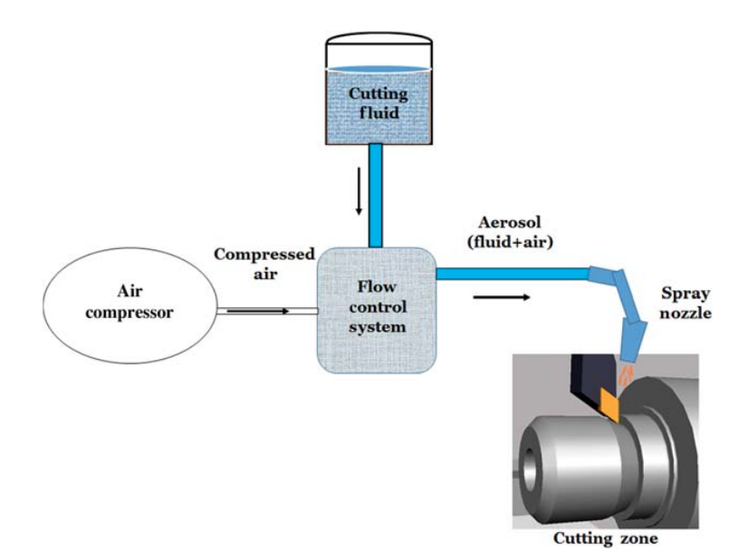
Figure 4 Schematic sketch of external feed MQL[20]

Types:
Based on how the cutting fluid is fed onto the cutting zone, the MQL techniques can be classified into external and internal feed MQL systems [21].

External feed MQL system:
Like the one shown in Figure 4, this system consists of an air compressor, a cutting fluid reservoir, an aerosol generator, and an external nozzle. This method can produce an oil droplet with 0.5 µm - 5 µm diameter.

The cutting fluid and air combine separate channels to create an aerosol mixture sprayed onto the cutting zone with a nozzle installed on the spindle head. This aerosol mixture is mixed close to the cutting zone.

Internal feed MQL system:
In this method, a continuous supply of the aerosol mixture is fed directly onto the cutting zone through the spindle via microchannels in the cutting tool. Because a special type of cutting tool is required for this method, the initial investment is higher.

This method is best suited for complex machining operations, which can be achieved at high cutting speeds. A major issue that could arise in this method is the formation of mist, which could result in ineffective lubrication.

Internal feed MQL systems can be further classified into single- and two-channel mixing systems based on the number of passages used to cut fluid and air to form the aerosol mixture.

Cryogenic MQL machining:
Cryo-MQL machining is a hybrid lubrication/cooling technique that involves simultaneous application of Minimum Quantity Lubrication (MQL) and liquid nitrogen (LN2) for better lubrication and cooling during machining.

In this technique, MQL provides a small amount of cutting fluid to the machining zone, while LN2 provides cooling to the cutting tool and workpiece. The combination of MQL and LN2 provides better lubrication and cooling than either technique alone, resulting in reduced temperatures at the cutting edge.

Analysis method
This research study used non-destructive analysis techniques, such as X-ray diffraction and optical profilometry, to examine the machined workpiece and compare the resulting data. All workpieces were subjected to these analysis techniques; their detailed understanding is discussed in this section, and the results obtained are discussed further in Section 4.

X-ray diffraction
X-ray diffraction analysis (XRD) is a non-destructive technique that employs monochromatic X-rays to determine the crystallographic structure, chemical composition, and physical properties of a workpiece material[28]. This analysis method effectively comprehends structural parameters such as average grain size, crystal defects, strain, and crystallinity [29].

In this procedure, an X-ray beam is directed at the examined object, and an X-ray detector collects the reflected X-rays from the object. These reflected X-ray signals from the workpiece are processed and graphed, displayed in the output unit [30].

The required structural composition of the workpiece material is determined by the peaks in the intensity versus displacement ($θ$) graph, as shown in Figure 5. Since the wavelength of X-rays is similar to the distance between atoms in a crystal, the interference effect of diffraction is used to measure the distance between atoms.

X-ray interactions determine whether constructive or destructive interference occurs. When the X-ray waves are aligned, and the signals are amplified, constructive interference is observed, whereas destructive interference is observed when the X-ray waves are out of alignment.

Bragg’s law helps to determine the relation between the exact angle of diffraction and the spacing between the atoms using Equation 3, where n is an integer, $λ$ is the X-ray wavelength, and d is the distance between the atoms.

$nλ=2d Sinθ$ Equation 3
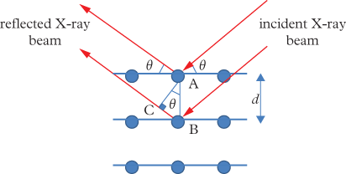

Figure 5 Schematic sketch of Braggs law[31]

The target workpiece is struck with accelerated electrons generated using a cathode ray tube within the X-ray tube. A characteristic X-ray spectrum is produced when the accelerated electrons have higher energies to dislodge the electrons present on the outer surface of the target workpiece material.

This reflected spectrum is observed by an X-ray detector, which is signal processed and further converted to the required signal that is displaced onto the monitor. The simple sketch depicting the various components used in an X-ray diffraction system is shown in Figure 6.
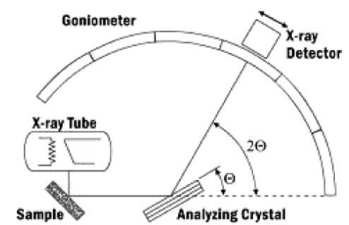
Figure 6 Schematic sketch of the X-ray diffraction system[29]
This research project selected the X-ray diffraction technique for the following advantageous reasons[29]:
- Sample preparation was simple and time-efficient.
- Since it was non-destructive, multiple tests on the same workpiece could be conducted if necessary.
- There is a large database of standards for various materials.

Surface roughness using optical profilometry
Surface roughness refers to the amount of finely spaced micro-irregularities on the surface texture, also known as roughness, waviness, etc. It is essential to cut with a low chip load to achieve a high level of surface finish and precision in machining operations.

Since surface roughness worsens with increasing chip load as it is the most significant factor influencing surface roughness. In contrast, surface roughness decreases when high feed and depth of cut are utilized due to dynamic behaviour (low vibration). With increasing chip load, the surface roughness of a machined chip decreases until embedded built-up edges become prominent[32].

Optical profilometry is one of the several ways to determine the surface roughness. It has been demonstrated that optical profilometers have benefits over mechanical profilometers because they provide the benefit of contactless scanning, which eliminates surface deformation and damage.

Furthermore, optical profilometers may scan surfaces that mechanical devices cannot connect to, such as a clear layer plate. This measurement form may be used to determine the roughness of the texture's distortion under different settings.

Interferometry and focus error detection are two distinct ideas frequently used in optical profilometry. This technique is also known as surface metrology because it employs coherence scanning interferometry to generate a surface topographic image, allowing for rapid data acquisition. It can cause large sections of surface roughness [33].

The principle behind is a single beam of light is split into two paths where the reference path length is fixed, and the test path length is scanned. The recombined paths are then measured at the detector, which produces an interferential pattern based on the phase difference of the arriving signals and the sum. Figure 7 depicts the operating concept of optical profilometry in a straightforward and self-explanatory manner.

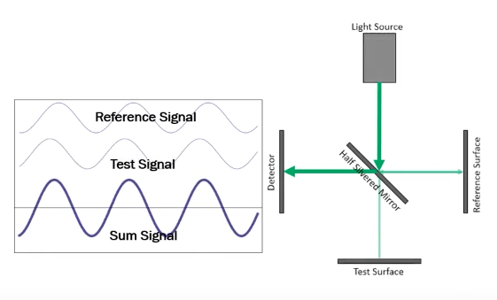
Figure 7 Schematic sketch of optical profilometry[34]
To illustrate the advantages and disadvantages of optical profilometry in comparison to other techniques and methodologies, it has the advantage of capturing the real area of imaging with quick acquisition (typically less than ten seconds per image) and a high variable field of view (FOV), it is a non-contact, non-destructive method, and it can automatically stitch images together, allowing the surface to be measured in a realistic amount of time. There are certain drawbacks, such as that the resolution is equivalent to that of an optical microscope and cannot measure massive objects. This method may be used to compute step height, critical dimensions, thickness, conformality, and surface roughness[34].

Experimental setup
The following experimental procedure was developed to comprehend the surface integrity parameters of hardened Vanadis 8. Surface integrity is primarily assessed using parameters such as micro-cracks, surface roughness, layer formation, residual stress, and surface morphology [35], which were investigated in this study using x-ray diffraction and optical profilometry techniques.

During the research, turning operations with carbon boron nitride (CBN) cutting inserts were performed on the Vanadis 8 workpiece. CBN cutting inserts were manufactured by Sandvik Coromant AB, and the generated cutting forces were measured using a dynamometer connected to the tool holder.

The three cutting conditions, dry, emulsion, and cryogenic MQL, were performed on each workpiece to compare surface integrity parameters. Accu Svenska AB supplied the lubrication system. The experiments were conducted at the Department of Industrial and Material Science in Chalmers University of Technology. The details of the experimental setup are discussed in the below sections.

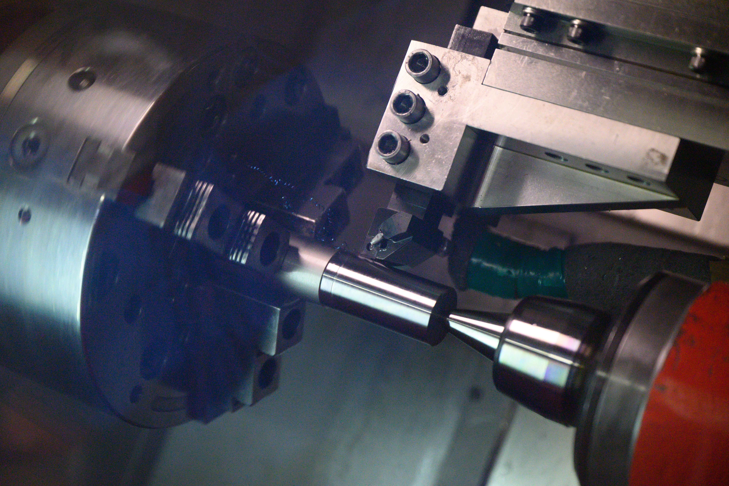
Experimental picture 1:Experimental Setup of Tool at Metal Cutting Research Lab, Chalmers

Workpiece used
The workpiece was manufactured at Uddeholm Vanadis 8 Super clean material. When compared to cold-worked SS2310, this has nearly twice the resistance to abrasive wear, adhesive abrasion, resistance to chipping, and toughness [4].

Uddeholm recommended a heat treatment cycle for Vanadis 8 that included austenite between 1870 °C -2150 °C and tempering at 1000 °C or higher [36]. The workpieces were all cylindrical, with similar dimensions and hardness of 60-62 HRC.

Residual forces generation
The dynamometers attached to the tool holders were used to measure the residual forces generated on the workpiece during machining. Each dynamometer is positioned to measure the cutting, feed, and passive residual forces. The generated cutting forces for each of the experiment's cutting speeds are depicted in Graph 1.

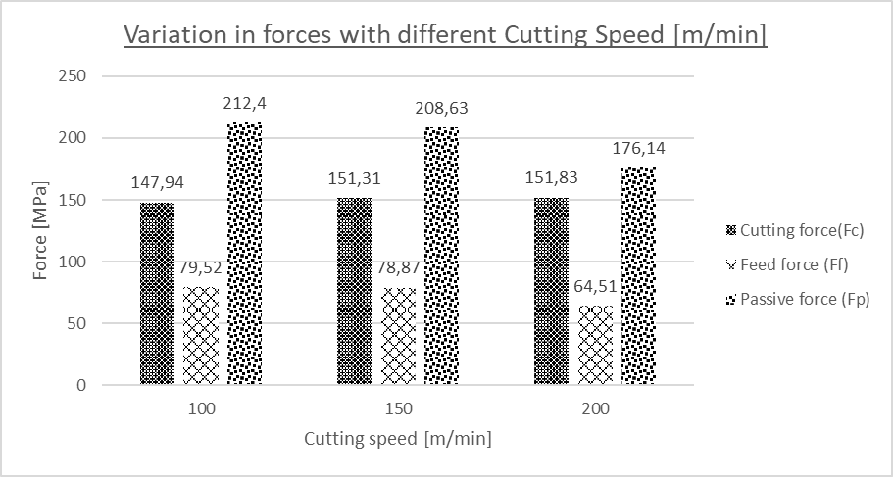
Graph 1 Variation in forces concerning different cutting forces

Tool inserts and holder
The turning operation was performed on an EMCO 365 CNC machine with Kistler 9275A dynamometers recording the cutting, passive, and feed forces during the machining process. Sandvik Coromant's specially designed tool holder was implemented with two nozzles aimed at the cutting edge. Cutting inserts CNMG 120408F-HGR 7125 and CNMG 432G-HGR 7125 were chosen.

Experimental picture 2 Emulsion-based machining process

Lubricant
External feed cutting MQL system was used in turning operations, with the lubricant being Accu- Svenska AB's Ecolubric ® minimal lubricant system. A liquid nitrogen cylinder replaced the compressed air cylinder to introduce a cryogenic environment into the MQL machining process.
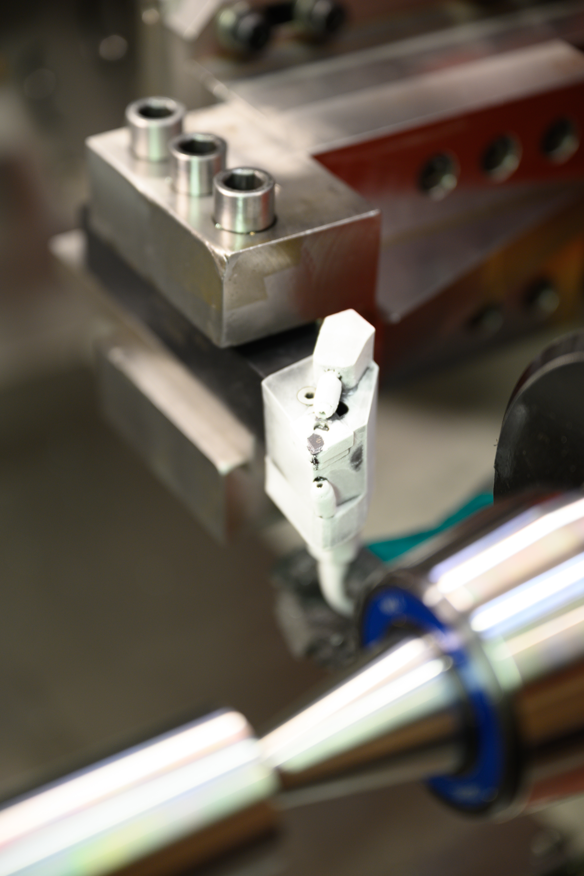
Experimental picture 3 Tool cutting at MCR lab using CRYO-MQL

Temperature optimisation
At the same depth of cut and feed rate of 0.15mm and 0.15mm/rev, respectively, different temperatures were used, as shown in Table 2. Two cutting speeds of 50 m/min and 100 m/min were performed for each temperature step. It was observed that there was no change in tool wear (130 microns) for temperature steps of -15 °C, -30 °C, and -40 °C.

Table 2 Parameters for Temperature Optimisation
F [mm/rev] | 0.15
a_{p}[mm] | 0.15
Temperature[°c] | -5 |  | -10 |  | -15 |  | -30 |  | -40
V_{c} [m/min] | 50 | 100 | 50 | 100 | 50 | 100 | 50 | 100 | 50 | 100

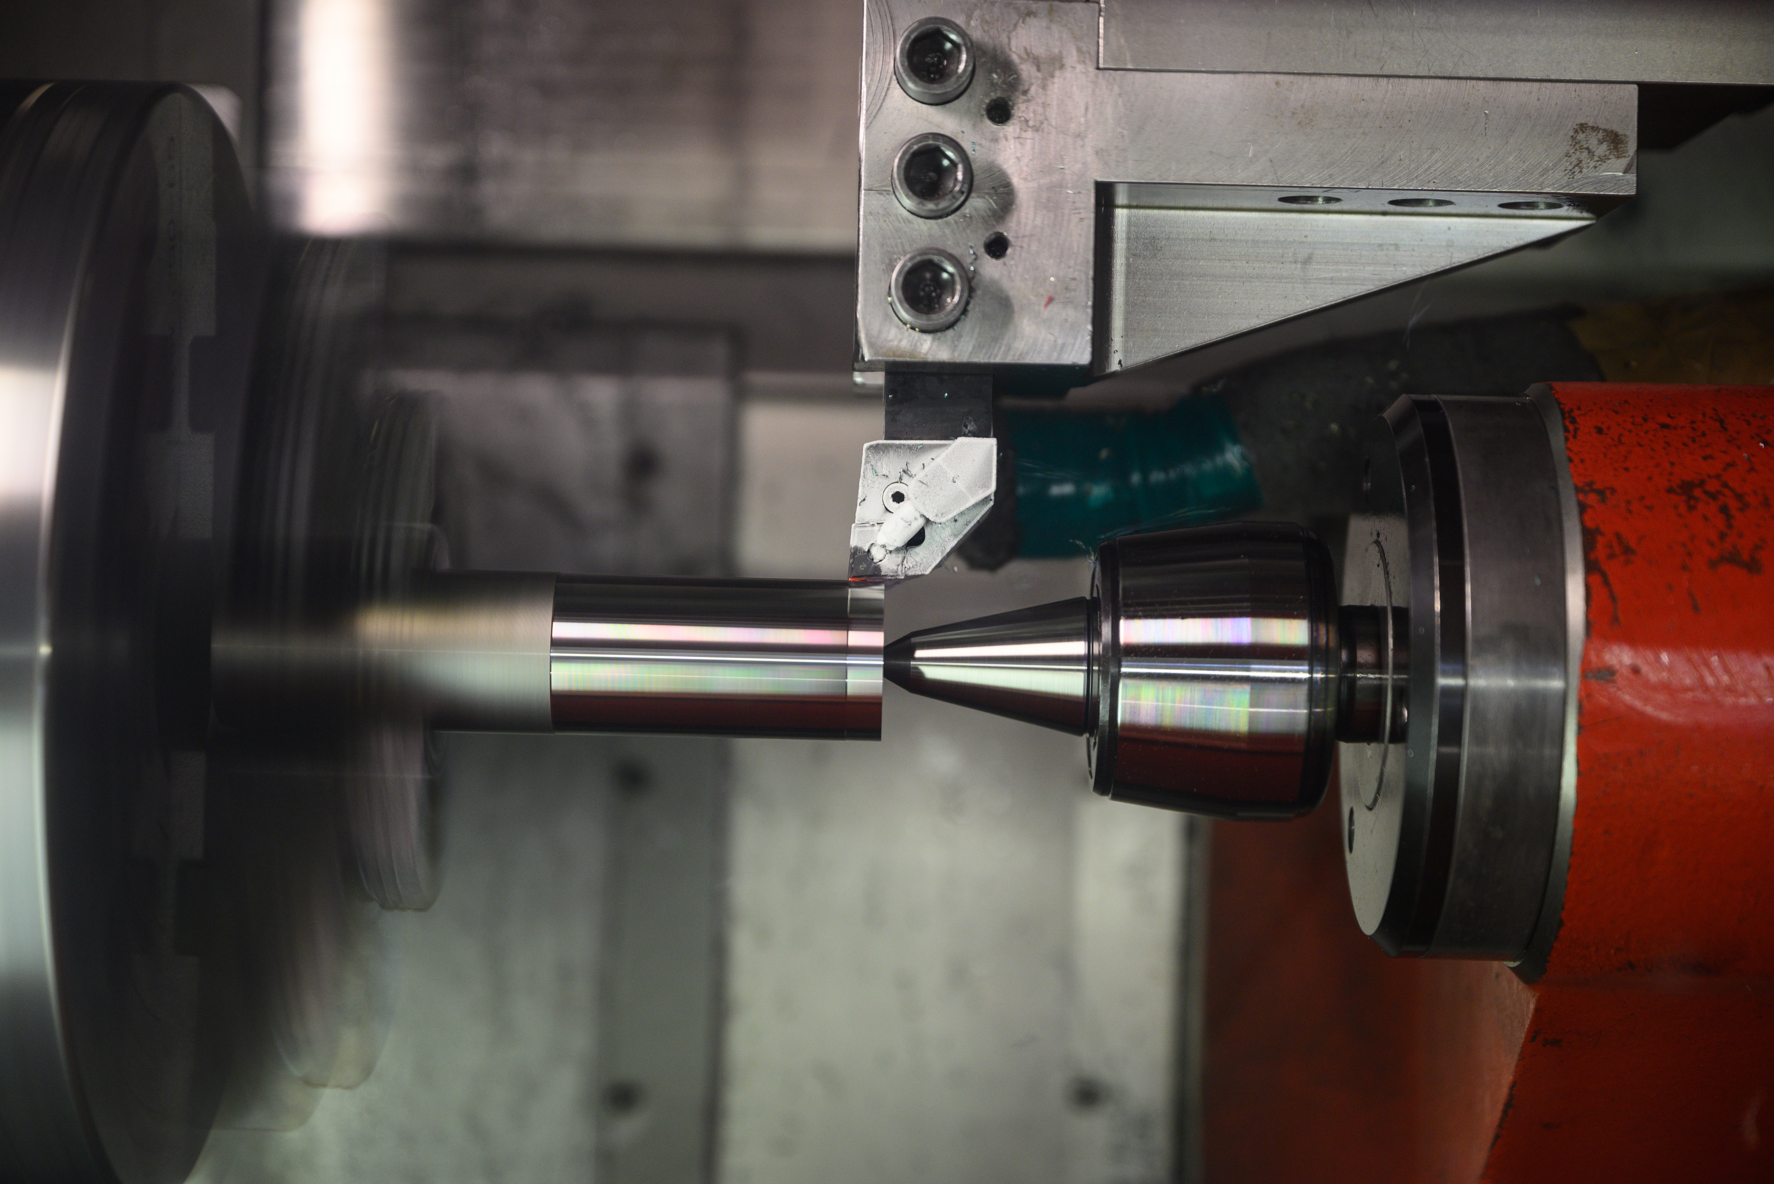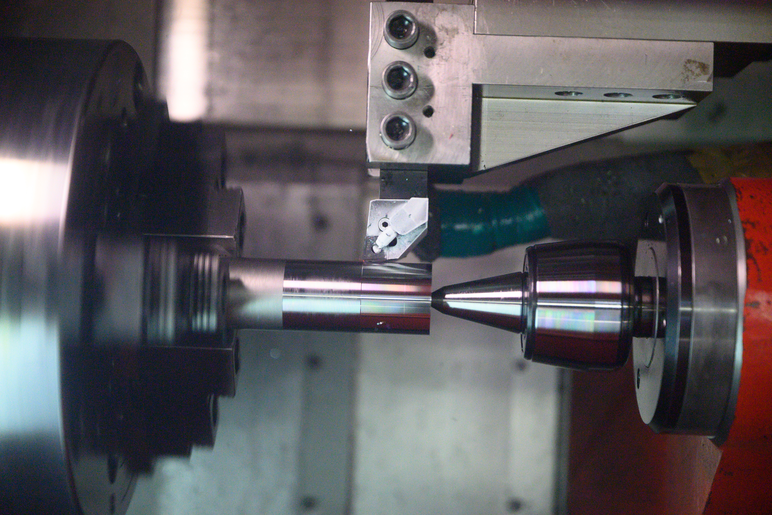
Experimental picture 4 Comparison of -10 °C and -40 °C CRYO-MQL-based machining process

Cutting speed optimisation
Table 3 shows the parameters used to optimize the cutting speed. The same cutting forces were observed in each scenario, and tool wear increased with increasing cutting speed. As it was determined from Table 1 that there was no significant variation in the cutting parameters of feed and depth, cutting speeds of 50 m/min, 100 m/min, and 150 m/min were selected for the experiments.
Table 3 Parameters for cutting speed optimisation
V_{c} [m/min] | F [mm/rev] | a_{p}[mm]
100 | 0.15 | 0.15
150 | 0.15 | 0.15
200 | 0.15 | 0.15

Sampling nomenclature
Each sample was labelled with three to four notational spaces, with the first two notations representing the test performed and the next two representing the sample number. All the tests in this study are conducted in real-time, hence the R and T designation at the first two notational spaces. If a workpiece is duplicated, a fourth notational number is used. RT3 is an example of a real-time workpiece sample, and RT33 is a duplicate of RT3 that would be subjected to the same cutting conditions and parameters. This could be observed in rows 1 and 2 in Table 4 for reference.

Experimental results and discussion
Experiments were conducted with three cutting conditions: dry, emulsion, and cryogenic MQL. Surface roughness and residual stresses induced on machined workpieces were the surface integrity parameters that were extensively studied.

For predicting induced stresses, the MQL technique used cryogenic temperatures of -10 °C and -40 °C, the same samples were used for surface roughness measurements. Three measuring points (spots) on the workpiece were considered for the surface roughness analysis, whereas only two measuring points were considered for the induced stress analysis tests.

The nomenclature for naming the workpiece is discussed in Section 2.7, and the spots 3 and 4 shown in Graphs 2a, 2b, 3a, 3b, 4a, 4b, 5a and 5b are the spots 1 and 2 of the duplicated workpiece, respectively.

Residual stresses results

To optimize the cutting speed and temperature for induced stress analysis, 50, 100, and 150 meters per minute were selected as cutting speeds. Two directions of the workpiece were considered for measuring the stresses: the direction of cutting and the direction of feed. To confirm the stresses generated under each cutting condition, duplicate samples were taken for each workpiece. The details of cutting conditions are provided in the following sections. In total, 24 samples were used for the analysis, and residual stresses were measured at two locations, namely spot one and spot two, after etching the samples.

Residual stresses during the Dry coolant technique
The summary of the residual stresses induced by the dry coolant technique is shown in Table 4, and the comparison for each individual spot generated on the workpiece (spots 1 and 2) and the duplicated workpiece (spots 3 and 4) is shown in Graph 2a and Graph 2b.
Table 4 Summary of residual stress using dry coolant technique
Coolant-Dry | Cutting Speed | Spot 1 |  |  |  | Spot 2
Coolant-Dry | Cutting Speed | Feed  direction |  | Cutting  direction |  | Feed  direction |  | Cutting  direction
Test number | V_{c}  [m/min] | Stress  [ MPa] | Statistical error [±] | Stress  [ MPa] | Statistical error [±] | Stress  [ MPa] | Statistical error [±] | Stress  [ MPa] | Statistical error [±]
RT1 | 50 | -579 | 2.9 | -536.6 | 44.6 | -574.5 | 14.6 | -508 | 34.4
RT11 | 50 | -512.6 | 6.2 | -385.1 | 45 | -525.1 | 8.8 | -361.3 | 33.2
RT2 | 100 | -507.7 | 7.5 | -517 | 44.2 | -508.9 | 17.8 | -467.6 | 32.8
RT22 | 100 | -540.5 | 9.6 | -603 | 42.7 | -520.1 | 20.6 | -457.6 | 34.1
RT3 | 150 | -322.7 | 6.3 | -198.1 | 43.8 | -281.7 | 12.2 | -142 | 38.1
RT33 | 150 | -368.7 | 22.4 | -258.5 | 30.9 | -269.9 | 15 | -134.5 | 39.7

Graph 2 a(top) Residual stresses using dry coolant at various cutting speeds based on Cutting direction

Graph 2 b(bottom) Residual stresses using dry coolant at various cutting speeds based on Feed direction
From Graphs 2a and 2b, for both the cutting and feed directions, residual compressive stresses were significantly lower at 150 m/min cutting speed compared to 50 m/min and 100 m/min cutting speeds when dry lubrication was used. At 50 m/min and 100 m/min cutting speeds, residual stresses exhibit a similar trend in both directions.

Comparing the residual stresses, the compressive stresses were marginally greater in the feed direction. The residual stresses at spot 1 of the duplicated workpieces were lower than those of the original workpiece, whereas spot 2 and 3 was significantly higher. The highest average residual stresses, 529 MPa, were measured in the feed direction at a cutting speed of 50 m/min, while the lowest, 89 MPa, were measured in the cutting direction at a cutting speed of 150 m/min.

Residual stresses emulsion coolant technique
The summary of the stresses induced by the emulsion coolant technique is shown in Table 5, and the comparison for each individual spot generated on the workpiece (spots 1 and 2) and the duplicated workpiece (spots 3 and 4) is shown in Graphs 3a and 3b.

Table 5 Summary of residual stress using emulsion coolant technique
Coolant-Emulsion | Cutting Speed | Spot 1 |  |  |  | Spot 2
Coolant-Emulsion | Cutting Speed | Feed  direction |  | Cutting  direction |  | Feed  direction |  | Cutting  direction
Test number | V_{c}  [m/min] | Stress  [ MPa] | Statistical error [±] | Stress  [ MPa] | Statistical error [±] | Stress  [ MPa] | Statistical error [±] | Stress  [ MPa] | Statistical error [±]
RT4 | 50 | -651.2 | 3.5 | -423.8 | 48.7 | -642 | 10.8 | -382.2 | 40.8
RT44 | 50 | -680.6 | - | -478.8 | - | -669.6 | 13.6 | -482.2 | 39.2
RT5 | 100 | -574 | 7.4 | -524.4 | 41.4 | -568.7 | 15.4 | -464.2 | 34
RT55 | 100 | -601.8 | 7.2 | -508.9 | 44.6 | -607.5 | 15.7 | -497.5 | 33.8
RT6 | 150 | -498.9 | 12.3 | -325.5 | 45 | -508.8 | 12.5 | -348.6 | 42.3
RT66 | 150 | -451.9 | 9.4 | -275.6 | 47.2 | -495.6 | 18 | -402.9 | 36.8

Graph 3a Residual stresses using emulsion coolant at various cutting speeds based on Cutting direction

Graph 3b Residual stresses using emulsion coolant at various cutting speeds based on Feed direction
Even at 150 m/min cutting speeds, the emulsion-based lubrication technique resulted in significantly greater residual compressive stresses than the dry lubrication technique. Residual stresses in the direction of feed are greater than stresses generated in the direction of cut. In the cutting direction, the highest compressive stresses were recorded at 100 m/min, whereas in the feed direction, the highest compressive stresses were recorded at 50 m/min. On the original workpieces, the compressive stresses in feed directions at spots 1 and 2 were quite similar for all cutting speeds. In contrast, spot 2 had more measurements than spot 1 in the cutting directions, except at 150 m/min.

Residual stresses during Cryo MQL (T= -10°C) coolant technique
The summary of the stresses induced for the Cryogenic MQL technique at a temperature of -10 °C is shown in Table 6, and the comparison for each individual spot generated on the workpiece (spots 1 and 2) and the duplicated workpiece (spots 3 and 4) is shown in Graphs 4a and 4b.
Table 6 Summary of residual stress using Cryo MQL (T=-10 °C) coolant technique
Coolant- Cryo MQL  (T= -10°c) | Cutting Speed | Spot 1 |  |  |  | Spot 2
Coolant- Cryo MQL  (T= -10°c) | Cutting Speed | Feed  direction |  | Cutting  direction |  | Feed  direction |  | Cutting  direction
Test number | V_{c}  [m/min] | Stress  [ MPa] | Statistical error [±] | Stress  [ MPa] | Statistical error [±] | Stress  [ MPa] | Statistical error [±] | Stress  [ MPa] | Statistical error [±]
RT7 | 50 | -609.2 | 5.2 | -502.8 | 44.9 | -633.1 | 11.8 | -502.8 | 38
RT77 | 50 | -524.1 | 4.2 | -354 | 42.7 | -565.6 | 8.8 | -391.1 | 34
RT8 | 100 | -508.2 | 14.8 | -469.8 | 38.7 | -516.3 | 18.4 | -485.8 | 34
RT88 | 100 | -493.8 | 10.6 | -345.7 | 37.8 | -493.2 | 16.8 | -346.3 | 34
RT9 | 150 | -279.3 | 7.7 | 84.1 | 43.8 | -287 | 11.7 | 55.7 | 41.4
RT99 | 150 | -242.5 | 14.4 | -73.5 | 33.5 | -303.2 | 15.7 | -71.2 | 42.1

Graph 4 a(top) Residual stresses using Cryo MQL (T= -10 °C) coolant at various cutting speeds based on Cutting direction

Graph 4 b(bottom), Residual stresses using Cryo MQL (T= -10 °C) coolant at various cutting speeds based on Feed direction
Using the MQL method with cryogenic lubricant at -10 °C, the results of residual stresses decreased as the feed direction cutting speeds increased. A similar trend can be observed in the cutting direction, but there were not many variations at 50 and 100 m/min speeds. At 150 m/min in the cutting directions, tensile residual stresses were generated on the workpiece, but compressive stresses were generated on the duplicated workpieces, resulting in disparate values. In most instances, the duplicated workpieces exhibited lower stresses than the original workpieces.

Residual stresses during Cryo MQL (T= -40 °C) coolant technique
The summary of the stresses induced for the Cryogenic MQL technique at a temperature of -40 °C is shown in Table 7, and the comparison for each individual spot generated on the workpiece (spots 1 and 2) and the duplicated workpiece (spots 3 and 4) is shown in Graphs 5a and 5b.
Table 7 Summary of residual stress using Cryo MQL (T=-40 °C) coolant technique
Coolant- Cryo MQL  (T= -60°c) | Cutting Speed | Spot 1 |  |  |  | Spot 2
Coolant- Cryo MQL  (T= -60°c) | Cutting Speed | Feed  direction |  | Cutting  direction |  | Feed  direction |  | Cutting  direction
Test number | V_{c}  [m/min] | Stress  [ MPa] | Statistical error [±] | Stress  [ MPa] | Statistical error [±] | Stress  [ MPa] | Statistical error [±] | Stress  [ MPa] | Statistical error [±]
RT10 | 50 | -472.1 | 3.2 | -215.9 | 38.3 | -469.4 | 6.5 | -236.3 | 36.9
RT100 | 50 | -559.1 | 8.7 | -369.4 | 37 | -550.3 | 14.1 | -392.6 | 37
RT11 | 100 | -518.5 | 14.8 | -465.6 | 41.2 | -504.8 | 18.6 | -490.9 | 36.9
RT111 | 100 | -560.6 | 16.7 | -473.1 | 37 | -537.3 | 16.1 | -472.3 | 26.8
RT12 | 150 | -330.1 | 10.5 | -74.2 | 44.4 | -317 | 11 | -41.7 | 40.4
RT122 | 150 | -331 | 13.8 | -28.6 | 43.7 | -360.7 | 14.3 | -93.3 | 38.3

Graph 5 a Residual stresses using Cryo MQL (T= -40 °C) coolant at various cutting speeds based on Cutting direction

Graph 5 b Residual stresses using Cryo MQL (T= -40 °C) coolant at various cutting speeds based on Feed direction
When the cryogenic lubricant was used at -60 °C, the residual stresses in the cutting direction decreased significantly when the material was machined at 50 m/min. The outcomes were similar when machined at 100 m/min for both -60 °C and -10 °C temperatures. No tensile stresses were generated at 150 m/min, but compressive stresses were the lowest in the cutting direction. In most cases, the results obtained for the duplicated workpieces were slightly higher than that of the original workpieces, except for the cutting directing when machined at 100 m/min.

Stresses induced for unmachined workpieces.
To cross-verify the results obtained and validate the values of the residual forces generated, a total of 16 unmachined workpieces were examined for residual stresses in the feed and cutting directions. These results are presented in Table 8, and the comparison is illustrated in Graph 6. In most tests, tensile stresses are generated on unmachined workpieces, as evidenced by these comparisons.
Table 8 Summary of residual stresses induced in unmachined workpieces
Sample number | Feed Direction |  | Cutting direction
Sample number | Stress  [ MPa] | Statistical error [±] | Stress  [ MPa] | Statistical error [±]
1 | 11.3 | 6.1 | 50.7 | 26.4
2 | 68.4 | 6.3 | 117.4 | 29.7
3 | 64.9 | 8.2 | 128.5 | 26
4 | -8 | 5.3 | 59.4 | 26.9
5 | 51.7 | 7 | 118.6 | 29.4
6 | 51.8 | 5.3 | 97.6 | 22.9
7 | 21.5 | 6.6 | 93.5 | 28.1
8 | -2.3 | 6.6 | 34.8 | 25.9
9 | 11.5 | 5 | 65.3 | 30.3
10 | -1.3 | 5 | 74.9 | 27.9
11 | 56.5 | 8.4 | 125.4 | 34.2
12 | -30.9 | 5.5 | 42.8 | 24.6
13 | 39.7 | 5.5 | 85.6 | 20.3
14 | 43.9 | 5.9 | 83.7 | 27.2
15 | -35.3 | 6.6 | 36.7 | 31.1
16 | 31.1 | 6.8 | 85.4 | 30.6

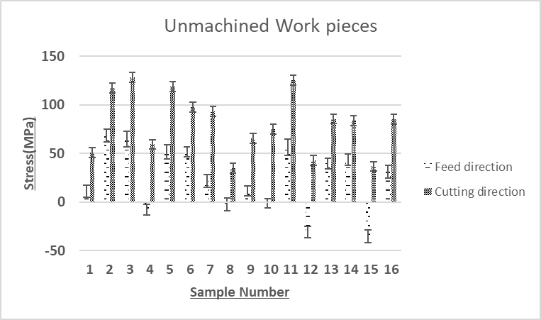
Graph 6 Residual stress comparison for unmachined workpieces
On the majority of unmachined workpieces, only tensional stresses were generated. The stresses in the direction of cutting were significantly greater than those in the direction of feed.

Verification of stresses induced results
All cutting conditions were repeated on a new set of machined pieces with a single measurement point, and the results are presented in Table 9. Graphs 7a and 7b compares residual stresses for all cutting conditions for both feed and cutting directions. The generated residual stresses are comparable to those obtained previously in Table 4, Table 5, Table 6, and Table 7.

In order to reduce the time and expense required for etching and measuring, only one location was considered. Although -40 °C instead of -60 °C is used in the MQL technique, there was no significant difference, proving that the temperature has been optimized.
Table 9 Verification of dry lubrication stresses
V_{c} [m/min] | Dry
V_{c} [m/min] | Cutting direction |  | Feed  direction
V_{c} [m/min] | Stresses  [MPa] | Error  [±] | Stresses  [MPa] | Error  [±]
50 | -536.6 | 44.6 | -579 | 2.9
50 | -508 | 34.4 | -512.6 | 6.2
100 | -517 | 44.2 | -507.7 | 7.5
100 | -467.6 | 32.8 | -540.5 | 9.6
150 | -198.1 | 43.8 | -322.7 | 6.3
150 | -142 | 38.1 | -368.7 | 22.4

Table 10 Verification of emulsion lubrication stresses
V_{c} [m/min] | Emulsion
V_{c} [m/min] | Cutting  direction |  | Feed  direction
V_{c} [m/min] | Stresses  [MPa] | Error  [±] | Stresses  [MPa] | Error  [±]
50 | -423.8 | 48.7 | -651.2 | 3.5
50 | -482.2 | 39.2 | -669.6 | 13.6
100 | -524.4 | 41.4 | -574 | 7.4
100 | -508.9 | 44.6 | -601.8 | 7.2
150 | -348.6 | 42.3 | -508.8 | 12.5
150 | -402.9 | 36.8 | -495.6 | 18

Table 11 Verification of cryo MQL based stresses at -10°C
V_{c} [m/min] | Cryo MQL(T-10)
V_{c} [m/min] | Cutting direction |  | Feed  direction
V_{c} [m/min] | Stresses  [MPa] | Error  [±] | Stresses  [MPa] | Error  [±]
50 | -402.2 | 37.7 | -598.7 | 9.7
50 | -396.5 | 39.1 | -570.1 | 11.8
100 | -516.8 | 36 | -570.1 | 16.3
100 | -615.1 | 32.1 | -578.5 | 16.8
150 | -154 | 40.4 | -333.6 | 14.3
150 | -290.6 | 36.8 | -351.5 | 15.5

Table 12 Verification of cryo MQL based stresses at -40 °C
V_{c} [m/min] | Cryo MQL(T-40)
V_{c} [m/min] | Cutting  direction |  | Feed  direction
V_{c} [m/min] | Stresses  [MPa] | Error  [±] | Stresses  [MPa] | Error  [±]
50 | -451.1 | 35.4 | -598.7 | 13.1
50 | -597 | 36 | -635.2 | 14.3
100 | -700.8 | 30.4 | -600.2 | 17.8
100 | -602.6 | 33.9 | -563.3 | 19.5
150 | -165 | 41.2 | -355.6 | 15.8
150 | -44.6 | 38.4 | -290 | 16.7

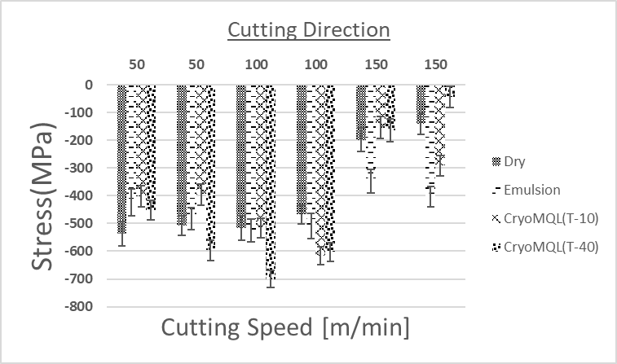
Graph 7 a(top) verification of residual stresses for various cutting conditions based on Cutting direction

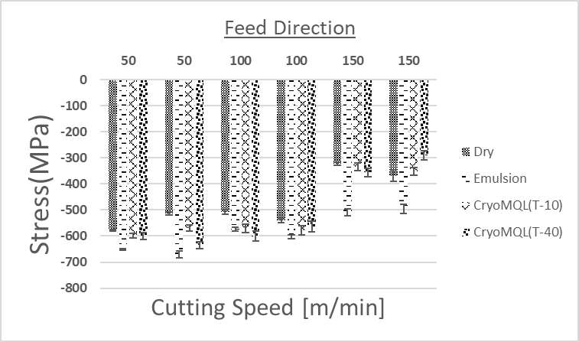
Graph 7 b(bottom) verification of residual stresses for various cutting conditions based on Feed direction
At a cutting speed of 150 m/min, residual stresses in both cutting and feed directions are reduced. The trend in all the graphs is comparable to the initial tests, with few variations in the results. When machined with emulsion-based lubrication, compressive stresses at 150 m/min were significantly higher than with other lubricating techniques.

Using cryo MQL lubrication at -40 °C, the stresses were higher on average at lower speeds of 50 m/min and 100 m/min, which decreased significantly at 150 m/min. The compressive stresses are tentatively lesser in the cutting direction than in the feed direction.

Surface roughness results
The surface roughness was measured at three different spots on the workpiece to obtain the average surface roughness parameter for the machine’s workpiece at the four cutting conditions.
Table 13 Surface roughness comparison with cutting conditions
Test no | Coolant technique | Cutting Speed  [m/min] | Surface roughness [μm]
Test no | Coolant technique | Cutting Speed  [m/min] | Spot 1 | Spot 2 | Spot 3 | Average
RT11 | Dry | 50 | - | 0.124 | 0.131 | 0.128
RT2 | Dry | 100 | 0.135 | 0.134 | 0.155 | 0.141
RT22 | Dry | 100 | 0.127 | 0.14 | 0.154 | 0.140
RT3 | Dry | 150 | 0.169 | 0.174 | 0.171 | 0.171
RT33 | Dry | 150 | 0.135 | 0.126 | 0.148 | 0.136
RT4 | Emulsion | 50 | 0.176 | 0.166 | 0.164 | 0.169
RT44 | Emulsion | 50 | 0.144 | 0.148 | 0.152 | 0.148
RT5 | Emulsion | 100 | 0.122 | 0.128 | 0.144 | 0.131
RT55 | Emulsion | 100 | 0.122 | 0.117 | 0.126 | 0.122
RT6 | Emulsion | 150 | 0.149 | 0.166 | 0.181 | 0.165
RT66 | Emulsion | 150 | 0.161 | 0.164 | 0.167 | 0.164
RT13 | CryoMQL  (T= -10°c) | 50 | 0.189 | 0.201 | 0.21 | 0.200
RT133 | CryoMQL  (T= -10°c) | 50 | 0.184 | 0.199 | 0.192 | 0.192
RT14 | CryoMQL  (T= -10°c) | 100 | 0.187 | 0.168 | 0.181 | 0.179
RT144 | CryoMQL  (T= -10°c) | 100 | 0.195 | 0.185 | 0.193 | 0.191
RT15 | CryoMQL  (T= -10°c) | 150 | 0.196 | 0.187 | 0.184 | 0.189
RT155 | CryoMQL  (T= -10°c) | 150 | 0.159 | 0.197 | 0.193 | 0.183
RT16 | CryoMQL  (T=-40°c) | 50 | 0.168 | 0.154 | 0.155 | 0.159
RT166 | CryoMQL  (T=-40°c) | 50 | 0.173 | 0.168 | 0.169 | 0.170
RT17 | CryoMQL  (T=-40°c) | 100 | 0.136 | 0.153 | 0.141 | 0.143
RT177 | CryoMQL  (T=-40°c) | 100 | 0.14 | 0.137 | 0.159 | 0.145
RT18 | CryoMQL  (T=-40°c) | 150 | 0.17 | 0.166 | 0.176 | 0.171
RT188 | CryoMQL  (T=-40°c) | 150 | 0.171 | 0.145 | 0.173 | 0.163

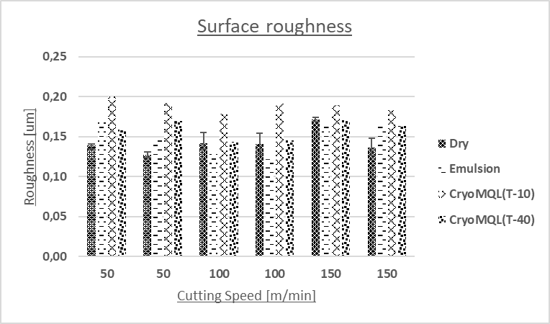
Graph 8 Average surface roughness results

The general trend observed in Graph 8 is that the surface roughness increases when the dry, emulsion, and cryogenic MQL techniques are utilized. When comparing only the cryogenic MQL lubricating technique, liquid nitrogen at -40 °C exhibited a smoother surface than liquid nitrogen at -10 °C. Additionally, the roughness ranged between 0.10µm and 0.20 µm in all instances. At 50 m/min cutting speed, dry-based lubrication resulted in the highest average surface roughness. In contrast, emulsion-based lubrication resulted in the lowest average surface roughness at 100 m/min cutting speed.

Conclusion and limitations
After conducting all the experiments and analysing all the results obtained on each workpiece under all cutting conditions, this section discusses the conclusion and future scope.

Etching for stress measurement and depth profiling
An electric charge creates the required depth profile on the workpiece during the etching process. The current design only creates a circular spot using a simple funnel technique. This setup can be improvised to create precise etching at the desired location. It is necessary to apply pressure between the workpiece and the etching tool so that the etchant does not leak during the etching process. This could facilitate an easy method for multiple etchings on the same spot, thereby enhancing the depth profile of the spot and the number of etchings performed.

Each successive etching process, performed at a specific temperature and time, increases the spot's depth. The depth profile was measured using a standard dial with a ball nose, which resulted in unreliable depth measurements; this measuring equipment can be upgraded with more accurate depth measuring equipment.

Conclusions from residual stress and surface roughness analysis

In the process of analyzing residual stress, experiments were conducted using different lubrication techniques with each cutting condition. The results obtained were interesting as they showed that residual stresses decreased with an increase in cutting speed, with the stresses being relatively more significant in the feed direction. At a cutting speed of 100 m/min, there was not much difference between emulsion-based lubrication and dry lubrication.

However, when the cutting speed was 50 and 150m/min, the residual stresses decreased slightly in the cutting directions but increased in the feed direction compared to stresses generated by emulsion-based lubrication. When using the MQL technique at a cryogenic temperature of -10 °C, the stresses generated were quite similar to those generated when using a dry lubricating technique in both the feed and cutting directions at all cutting speeds.

However, at a cutting speed of 150 m/min, tensile stresses were generated for the original workpiece while the duplicated workpiece exhibited lower compressive stresses. Using the MQL technique at a cryogenic temperature of -40 °C, at a cutting speed of 50 m/min resulted in lower residual stresses, no significant change at 100 m/min, and higher compressive stresses in the feed direction when compared to the dry lubricating technique. Comparing the same method with the MQL technique at -10 °C, compressive stresses recorded at 150 m/min were quite comparable.

Experiments demonstrated that the residual stresses were comparable for cutting speeds of 50 and 100 m/min but decreased dramatically for 150 m/min. This is because the feed rate (0.15 mm/rev) is the same at all cutting speeds, resulting in a lower rate of friction at slower speeds that dramatically increases at 150 m/min. This also increases tool wear at 150 m/min cutting speeds when using dry, emulsion, and cryo MQL lubrication techniques with liquid nitrogen at -10 °C and -40 °C. This demonstrates that the friction between the workpiece and cutting tool increases as cutting speed increases, resulting in increased tool wear.

To validate the results obtained using the residual stress technique, stresses were recorded on 12 unmachined workpieces. Most measurements obtained from unmachined workpieces revealed tensile stresses, which contradicts those obtained on machined workpieces. On a brand-new set of workpieces, a second set of measurements was taken, but this time, only one location on the workpiece was recorded when the residual stresses were measured.

The fact that the results of the new experiments were very similar to those of the original experiments demonstrates that the measurements are accurate. To test at different temperatures, this new series of experiments used cryogenic temperatures of -10 °C and -40 °C instead of -60 °C.

An optical profilometry technique measured surface roughness for all cutting conditions. Comparing the Cryo MQL technique to dry or emulsion-based techniques, it was discovered that surface roughness increases when Cryo MQL is used. Using a cryogenic lubricant at -10 °C produced the roughest surface; however, the surface roughness decreased with decreasing temperature, as it was slightly less at -40 °C than at -10 °C.

Future scope
- A sample of the machined workpieces can be kept under a scanning microscope to predict the formation of a white layer.
- For more precise depth profiles during the etching process, superior equipment that could generate vacuum pressure between the workpiece and the etching holder can be utilized.
- Profilometry is used to measure surface roughness; however, more advanced methods can be utilized to predict the surface roughness more accurately.

References
[1] World steel association, ‘About steel’. https://worldsteel.org/about-steel/about-steel/
[2] Metal supermarkets, ‘Tool Steel Applications and Grades’, Nov. 21, 2014. https://www.metalsupermarkets.com/tool-steel-applications-grades/ (accessed Oct. 06, 2022).
[3] Metal Supermarkets, ‘The Four Types of Steel (Part 5: Tool Steel)’. https://www.youtube.com/watch?v=-fZQ9ElnymI
[4] UDDEHOLMS AB, ‘Uddeholm Vanadis® 8 SuperClean’, Edition 4, Sep. 2016.
[5] M. Tidesten, A. Medvedeva, F. Carlsson, and A. Engström-Svensson, ‘A New Cold Work PM-Grade Combining High Wear Resistance with High Ductility’, BHM Berg- Hüttenmänn. Monatshefte, vol. 162, no. 3, pp. 117–121, Mar. 2017, doi: 10.1007/s00501-017-0581-z.
[6] E. L. Barbedo et al., ‘Analysis of Milling Efficiency of the Vanadis® 8 Tool Steel with Additions of Vanadium and Molybdenum Carbides’, Mater. Res., vol. 24, no. 5, p. e20210054, 2021, doi: 10.1590/1980-5373-mr-2021-0054.
[7] JONATHAN, ‘Detailed Vanadis 8 Steel Review’. https://knifebasics.com/detailed-vanadis-8-steel-review/ (accessed Jul. 20, 2022).
[8] Wallwork Heat Treatment Ltd, ‘Harden & Temper’. https://www.wallworkht.co.uk/content/harden_and_temper/#:~:text=Steels%20are%20heated%20to%20their,mechanical%20properties%20and%20relieves%20stresses. (accessed Jul. 20, 2022).
[9] Uddeholm, ‘Heat Treatment Guidelines’. May 06, 2018. [Online]. Available: www.uddeholm.com
[10] Turn tech precision, ‘10 Turning process you need to know’, Aug. 29, 2020. https://turntechprecision.com/clueless-machinist
[11] I. Edmund, ‘Calculated forces when turning’, Feb. 01, 2013. https://www.ctemag.com/news/articles/calculated-forces-when-turning#:~:text=The%20cutting%20force%20when%20turning,Kistler%20dynamometers%20the%20most%20accurate.
[12] R. Kshetri, ‘Modeling and Analysis of Three Components of Cutting Force During the Turning of Red Brass (C23000) Using Regression Analysis’, Int. J. Eng. Sci. Invent. IJESI, vol. 07, no. 06,2018, pp. 69–79.
[13] M. S. Chua, H. T. Loh, Y. S. Wong, and M. Rahman, ‘Optimization of cutting conditions for multi-pass turning operations using sequential quadratic programming’, J. Mater. Process. Technol., vol. 28, no. 1–2, pp. 253–262, Sep. 1991, doi: 10.1016/0924-0136(91)90224-3.
[14] C. Chung, P.-C. Wang, and B. Chinomona, ‘Optimization of turning parameters based on tool wear and machining cost for various parts’, Int. J. Adv. Manuf. Technol., vol. 120, no. 7–8, pp. 5163–5174, Jun. 2022, doi: 10.1007/s00170-022-09037-y.
[15] S. Thorat, ‘What is Cutting Speed,Feed ,Depth Of Cut in Machine tools’. https://learnmech.com/what-is-cutting-speedfeed-depth-of-cu/ (accessed Aug. 04, 2022).
[16] K. Zheng Yang et al., ‘Application of coolants during tool-based machining – A review’, Ain Shams Eng. J., p. 101830, May 2022, doi: 10.1016/j.asej.2022.101830.
[17] Sandvik Coromant, ‘How to apply coolant and cutting fluid in turning’. https://www.sandvik.coromant.com/en-gb/knowledge/general-turning/pages/how-to-apply-coolant-and-cutting-fluid-in-turning.aspx
[18] M. V. R. D. Prasad, T. Malyadri, and S. N. S. S. Hari, ‘Sensitivity analysis for process parameters influencing surface roughness of hardened steel in dry machining process’, Mater. Today Proc., vol. 26, pp. 2521–2524, 2020, doi: 10.1016/j.matpr.2020.02.536.
[19] T. Leppert and R. L. Peng, ‘Residual stresses in surface layer after dry and MQL turning of AISI 316L steel’, Prod. Eng., vol. 6, no. 4–5, pp. 367–374, Sep. 2012, doi: 10.1007/s11740-012-0389-3.
[20] S. Debnath, M. Anwar, A. Pramanik, and A. K. Basak, ‘Nanofluid-minimum quantity lubrication system in machining: towards clean manufacturing’, in Sustainable Manufacturing, Elsevier, 2021, pp. 109–135. doi: 10.1016/B978-0-12-818115-7.00014-6.
[21] V. Kharka and N. K. Jain, ‘Achieving sustainability in machining of cylindrical gears’, in Sustainable Manufacturing, Elsevier, 2021, pp. 391–426. doi: 10.1016/B978-0-12-818115-7.00002-X.
[22] J. Haider and M. S. J. Hashmi, ‘Health and Environmental Impacts in Metal Machining Processes’, in Comprehensive Materials Processing, Elsevier, 2014, pp. 7–33. doi: 10.1016/B978-0-08-096532-1.00804-9.
[23] Unist Inc., ‘What Is Minimum Quantity Lubrication (MQL)?’, Feb. 14, 2013. https://www.youtube.com/watch?v=aP3glc4HoWg
[24] B. Tai, D. Stephenson, R. Furness, and A. Shih, ‘Minimum Quantity Lubrication for Sustainable Machining’, in Encyclopedia of Sustainable Technologies, Elsevier, 2017, pp. 477–485. doi: 10.1016/B978-0-12-409548-9.10213-1.
[25] M. Mia, M. A. Rahman, M. K. Gupta, N. Sharma, M. Danish, and C. Prakash, ‘Advanced cooling-lubrication technologies in metal machining’, in Machining and Tribology, Elsevier, 2022, pp. 67–92. doi: 10.1016/B978-0-12-819889-6.00010-1.
[26] B. C. Behera, Chetan, S. Ghosh, and P. V. Rao, ‘The underlying mechanisms of coolant contribution in the machining process’, in Machining and Tribology, Elsevier, 2022, pp. 37–66. doi: 10.1016/B978-0-12-819889-6.00003-4.
[27] K. Gupta, N. K. Jain, and R. Laubscher, ‘Advances in Gear Manufacturing’, in Advanced Gear Manufacturing and Finishing, Elsevier, 2017, pp. 67–125. doi: 10.1016/B978-0-12-804460-5.00004-3.
[28] P. B. Raja, K. R. Munusamy, V. Perumal, and M. N. M. Ibrahim, ‘Characterization of nanomaterial used in nanobioremediation’, in Nano-Bioremediation : Fundamentals and Applications, Elsevier, 2022, pp. 57–83. doi: 10.1016/B978-0-12-823962-9.00037-4.
[29] A. A. Bunaciu, E. gabriela Udriştioiu, and H. Y. Aboul-Enein, ‘X-Ray Diffraction: Instrumentation and Applications’, Crit. Rev. Anal. Chem., vol. 45, no. 4, pp. 289–299, Oct. 2015, doi: 10.1080/10408347.2014.949616.
[30] Bruker Corporation, ‘What is X-ray Diffraction?’, May 29, 2019. https://www.youtube.com/watch?v=QHMzFUo0NL8&t=134s
[31] B. Cantor, ‘Bragg’s Law: Diffraction’, in The Equations of Materials, Oxford University Press, 2020, pp. 24–44. doi: 10.1093/oso/9780198851875.003.0002.
[32] M. Y. Ali and W. N. P. Hung, ‘1.11 Micromachining’, in Comprehensive Materials Finishing, Elsevier, 2017, pp. 322–343. doi: 10.1016/B978-0-12-803581-8.09156-6.
[33] M. Visscher and K. G. Struik, ‘Optical profilornetry and its application to mechanically inaccessible surfaces Part I: Principles of focus error detection’, Butterworth-Heinemann, vol. 16, no. 3, Jul. 1994.
[34] Penn State MRI, ‘Introduction to Optical Profilometry’, Dec. 30, 2021. https://www.youtube.com/watch?v=3cCNuv05NLM
[35] P. M. Pawar, B. P. Ronge, R. Balasubramaniam, A. S. Vibhute, and S. S. Apte, Eds., Techno-Societal 2018: Proceedings of the 2nd International Conference on Advanced Technologies for Societal Applications - Volume 2. Cham: Springer International Publishing, 2020. doi: 10.1007/978-3-030-16962-6.
[36] K. steel nerds Larrin, ‘Vanadis 8 – Better than CPM-10V’, Dec. 07, 2020. https://knifesteelnerds.com/2020/12/07/vanadis-8-better-than-cpm-10v/#:~:text=Heat%20Treatment%20of%20Vanadis%208,to%20go%20lower%20than%20that.

DEPARTMENT OF INDUSTRIAL ENGINEERING AND MATERIAL SCIENCE
CHALMERS UNIVERSITY OF TECHNOLOGY
Gothenburg, Sweden 20xx
www.chalmers.se
11


