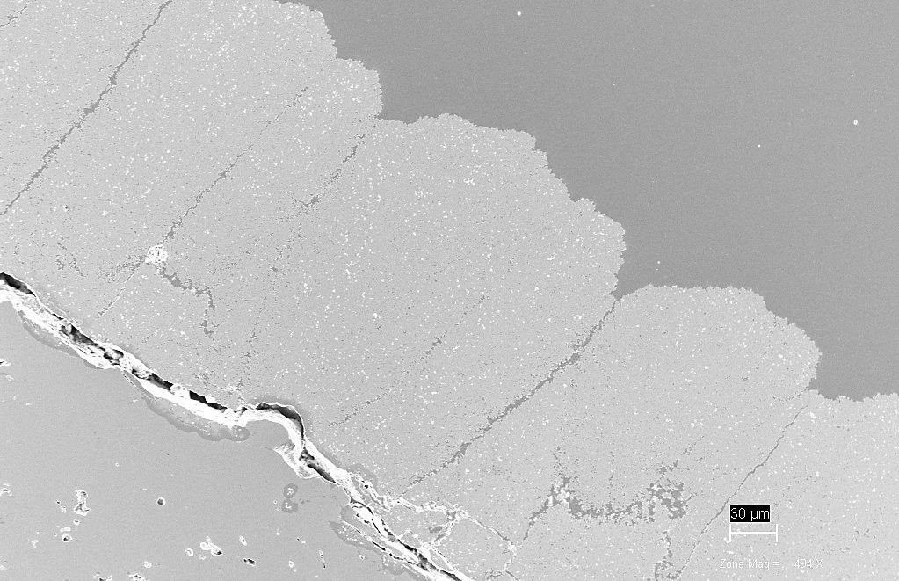
To edit footer choose “Footer” from the Insert tool bar and then choose “Edit footer”. After editing choose “Close header and footer”.
Characterization of Yttria Stabilized Zirconia thermal spray coatings by use of NMR Cryoporometry and SEM

Master’s Thesis in the Master’s Program Materials Engineering

CHARLOTTE CRONQUIST

Characterization of Yttria Stabilized Zirconia thermal spray coatings by use of NMR Cryoporometry and SEM

Master’s Thesis in the Master’s Program Materials Engineering
CHARLOTTE CRONQUIST

Department of Industrial and Material Science
Division of Materials and Manufacturing
Surface and Microstructure Engineering
Chalmers University of Technology
Göteborg, Sweden 2019
Characterization of Yttria Stabilized Zirconia thermal spray coatings by use of NMR Cryoporometry and SEM
CHARLOTTE CRONQUIST
Master’s Thesis in the Master’s Program Materials Engineering

© CHARLOTTE CRONQUIST, 2019

Department of Industrial and Materials Science
Division of Materials and Manufacturing
Surface and Microstructure Engineering
Chalmers University of Technology
SE-412 96 Göteborg
Sweden
Telephone: + 46 (0)31-772 1000

Cover:
SEM image of a Yttria Stabilized Zirconia top coat of a thermal barrier coating. The top coat has a columnar structure and it is partly detached at the thermally grown oxide layer situated at the interface to the bond coat.
Chalmers Reproservice, Göteborg, Sweden, 2019

Characterization of Yttria Stabilized Zirconia thermal spray coatings by use of NMR Cryoporometry and SEM
Master’s thesis in the Master’s Program Materials Engineering
CHARLOTTE CRONQUIST
Department of Industrial and Materials Science
Division of Materials and Manufacturing
Surface and Microstructure Engineering
Chalmers University of Technology

Abstract
Thermal Barrier Coatings (TBC) are of major importance in high temperature applications such as turbines, where temperatures above 1000°C are reached. The TBCs protect the base metal (i.e. the actual turbine) by providing a layer of material with low thermal conductivity and heat-transfer. Ceramic materials such as Yttria Stabilized Zirconia (YSZ) are suitable as TBC materials as they provide for heat resistant behavior. By tailoring the microstructure, the desired thermal conductivity and toughness can be achieved. Suspension Plasma Spraying (SPS) provides for this by forming a columnar microstructure containing both nano- and microporosity.

NMR Cryoporometry (NMRC) is a known method used to investigate pore size distribution and pore shape in organic materials. NMRC has also shown to be a promising analysis technique for ceramic material. This work aimed to investigate YSZ coatings produced by SPS with water as probe liquid. This allowed the measurement of pores of a few nanometers in diameter. Special care was taken to improve the sample preparation in order to achieve a suitable signal-to-noise ratio in the NMR-signal.

To capture the changes in the YSZ coatings during the sintering at high temperatures in a potential application (some pores will open up while others will close), as-sprayed and heat-treated samples were investigated, and pore size and shape were compared. The results are compared with previous measurements performed on the same material using Mercury Intrusion Porosimetry and Image Analysis as well as NMR Cryoporometry using another probe liquid (OMCTS).

Key words: Suspension Plasma Spraying, Yttria Stabilized Zirconia, nanoporosity, NMR Cryoporometry.
Karakterisering av termiska spraybeläggningar av Yttria Stabiliserad Zirkoniumoxid med användning av NMR-kryoporometri och SEM

Examensarbete inom mastersprogrammet Materials Engineering

CHARLOTTE CRONQUIST

Institutionen för Industri- och materialvetenskap
Avdelningen för Material och tillverkning
Yt- och mikrostrukturteknik
Chalmers tekniska högskola

Sammanfattning
Termiska barriärskikt har en stor betydelse inom högtemperaturapplikationer så som turbiner, där temperaturer över 1000°C uppnås. Barriärskikten skyddar basmetallen (alltså själva turbinen) genom att tillhandahålla ett lager av material med låg termisk konduktivitet och värmeöverföring. Keramiska material som Yttriumdioxid-stabiliserad zirkoniumdioxid (YSZ) är lämpliga material till termiska barriärskikt då de tillhandahåller värmebeständigt beteende. Genom att skräddarsy mikrostrukturen kan önskad termisk konduktivitet och seghet uppnås. Suspensions-plasmasprutning kan tillhandahålla detta genom att forma en kolumnär mikrostruktur som innehåller både nano- och mikroporositet.

NMR Kryoporometri är en välkänd metod för att undersöka pordistributionen och porgeometrin i organiska material. Metoden har också visat sig vara en lovande analysmetod för keramiska material. Syftet med det här arbetet var att undersöka YSZ-skikt producerade genom suspensions-plasmasprutning med vatten som sondvätska, vilket kan tillåta mätningar av porer på några få nanometer i diameter. Speciellt har det fokuserats på att förbättra provberedningen för att nå ett godtagbart signal-brus-förhållande i NMR-signalen.

För att fånga förändringarna i YSZ-skikten under sintring i höga temperaturer i en potentiell applikation (då några porer kommer att öppnas upp och andra slutas) undersöktes prover som värmebehandlats gällande porstorlek och porform och jämfördes med prov som ej värmebehandlats. Resultaten jämfördes sedan med mätningar som gjorts på samma material med Mercury Intrusion Porosimetry och bildanalys så väl som NMR Kryoporometri med en annan sondvätska (OMCTS).

Nyckelord: Suspensions-plasmasprutning, Yttriumoxid-stabiliserad Zirkoniumdioxid, nanoporositet, NMR-Kryoporometri

Acknowledgements

To make this thesis possible I must thank my husband for being the most supportive person ever known to mankind. You let me work undisturbed when needed and acted as my biggest supporter even during the darkest of times.

Also, thanks to my supervisor and examiner Uta Klement, not just for providing me with the topic of SPS and TBCs but also for many interesting discussions regarding the nanosized world.

A grateful thank is sent to the people helping me during the way. Associate Professor Lars Nordstierna, Department of Applied Surface Chemistry, Chalmers with the NMRC analysis. Satyapal, Ashish and Jonas from University West for taking the time to help me with the waterjet cutting and design of heat-treatment. Also Johan and Adrianna at Chalmers for help with the equipment and sample prepping. Thank you!

Göteborg, June 2019
Charlotte Cronquist

Contents
1 Introduction 1
1.1 Background 1
1.2 Aim 2
1.3 Limitations 2
2 Theoretical background 3
2.1 Material 3
2.1.1 General information of the thermal barrier coating 3
2.1.2 Yttria Stabilized Zirconia 4
2.2 Thermal spraying 5
2.2.1 Suspension Plasma Spraying 6
2.3 Analysis techniques 7
2.3.1 NMRC 7
2.3.2 SEM 10
3 Methodology 12
3.1 Spraying 12
3.2 Heat treatment 12
3.3 Sample preparations 12
3.3.1 NMRC 12
3.3.2 SEM 13
3.4 NMRC analysis 13
3.4.1 NMRC procedure 14
3.4.2 Modelling of the NMRC data 14
3.5 SEM 15
4 Results 16
4.1 NMRC 16
4.1.1 General information on the NMRC results 16
4.1.2 Hysteresis in the melting and freezing curves: 17
4.1.3 Pore geometry 20
4.1.4 Pore size distribution 22
4.1.5 Porosity 24
4.2 SEM 24
4.2.1 As-sprayed samples 25
4.2.2 Heat-treated samples 27
5 Discussion 29
5.1 Discussion on the results 29
5.1.1 NMRC 29
5.1.2 SEM 31
5.2 General discussion on the sample preparations for NMRC 31
6 Conclusion 33
7 Recommendations on further research 34
8 References 35
9 Appendix 38
A. Spraying parameters 38
B. Graphs used for determining geometry 39

Preface
This study on the porosity of Yttria Stabilized Zirconia was performed at Chalmers University of Technology during the spring of 2019, as the final part of my studies in Mechanical Engineering in the Master’s Program Materials Engineering. The project was carried out at the Department of Industrial and Materials Science, Surface and Microstructure technology. The thesis work was supervised by Professor Uta Klement who helped me with valuable discussions and understanding on why such as small thing as a pore is of importance for our future.

The NMRC analysis performed was carried out at the Swedish NMR-Center with the help of Lars Nordstierna, Dept. of Applied Surface Chemistry, Chalmers.

Göteborg, June 2019
Charlotte Cronquist
List of Abbreviations

TBC Thermal Barrier Coating
YSZ Yttria Stabilized Zirconia
APS Air Plasma Spraying
EB-PVD Electron Beam – Physical Vapor Deposition
SPS Suspension Plasma Spraying
NMRC Nuclear Magnetic Resonance Cryoporometry
SEM Scanning Electron Microscopy
MCrAlY Metal Chromium Aluminum Yttrium
TGO Thermally Grown Oxide
t’ Tetragonal prime phase
$Y_{2}O_{3}$ Yttria
$ZrO_{2}$ Zirconia
HVOF High Velocity Oxy-Fuel
B Magnetic field
M Magnetization
$ω$ Larmor Frequency
$T_{eq}$ Equilibrium temperature
V Volume
S Surface area
$F_{m}$ Helmholtz free energy for melting
$μ_{l}$ Chemical potential of liquid
$ν_{l}$ Molar volume of liquid
$γ_{lw}$ Surface energy of liquid/wall interphase
$F_{f}$ Helmholtz free energy for freezing
$μ_{s}$ Chemical potential of solid
$ν_{s}$ Molar volume of solid
$γ_{sl}$ Surface energy of solid/liquid interface
$S_{s}$ Surface area of solid
$V_{s}$ Volume of solid
$ΔF$ Free energy difference
$ΔH$ Enthalpy of fusion
$T$ Temperature
$T^{0}$ Transition temperature
$V_{l}$ Volume of liquid
$K$ Probe liquid constant
${ΔT}_{m}$ Melting temperature depression
$T_{m}^{∞}$ Melting temperature in bulk
$ρ_{s}$ Density of solid
$cos(ϕ)$ Wetting angle term
$k_{GT}$ Calibration constant
$x$ Size
OMCTS Octamethylcyclotetrasiloxane
$T_{f}$ Freezing temperature
$T_{f }^{c}$ Critical freezing temperature
r Radius
$D_{4}$ OMCTS
NMR Nuclear Magnetic Resonance
BSE Backscattered Electrons
EB Electron Beam
SE Secondary Electrons
FID Field Induction Decay
$T_{in}$ Temperature set in NMR-magnet
$I_{out}$ NMR signal out
$T_{m}$ Melting temperature
$T_{i}$ Calibrated $T_{eq}$ at i-th discrete step
$ΔT$ $T_{i}-T_{m}$
$I_{i}$ NMR-signal intensity in i-th step
$τ$ Non-freezing or pre-molten layer
$r_{m}, r_{f}$ Radius of melting/freezing pores
x-value Geometry factor
PSD Pore Size Distribution

Introduction
Below follows an introduction to the project regarding background, aim and limitations.

Background
With respect to materials, the world of high temperature applications provides for intriguing problems to solve. Land-based and aero-engine turbines are applications that require the material to be both tough and to withstand high temperatures, typically above 1000 ˚C, and still maintain its mechanical properties. To be able to endure the high temperatures, the engine will have to be cooled and have a thermal barrier coating (TBC) which protects the metal that the turbine or engine itself is built of.

A TBC-system is usually built up by three layers. The first is the substrate which is the metal that the component is based on, then there is a bond coat, and the outer layer is the top coat. There can also be additional layers of material such as thermally grown oxides, and layers protecting from melting of oxides. The top coat is the layer that provides the thermal insulation and is often a ceramic as they have superior thermal properties. The properties of the top coat determine how well the coating provides for the necessary protection and it is of great importance how the microstructure of the material is built up.

The properties of the top coat are dependent on the material by which it is made of and by the production method that has been used to produce it. To have enough thermal insulation, the material needs to have a certain amount of porosity, and the structure needs to withstand the cyclic thermal expansion to which it is exposed. These two properties mostly contradict each other since the porosity itself makes the material more brittle. Yttria Stabilized Zirconia (YSZ) has the thermal properties and the toughness for this and is a well-known material, however the porosity and the microstructure required is defined by the way the coating is produced. The cyclic thermal loading requires the material to expand and traditionally many coatings are built up by Air Plasma Spraying (APS). APS produces a lamellar structure which is not very strain tolerant when expanded. Other production methods such as Electron Beam Physical Vapor Deposition (EB-PVD) provide a columnar structure which expands in a more efficient way [1], but EB-PVD processing is much more expensive.

Suspension plasma spraying (SPS) is a new technique that has been shown to be able to generate a columnar structure. The technique allows for smaller particles to be used than in conventional spraying techniques. So far, the results have shown superior properties regarding the microstructure compared to coatings produced by APS or EB-PVD. There are however still some question marks regarding the pore size distribution in the nanometer range of the coatings produced. These pores could affect the thermal conductivity in the top coat [2]. Also, what might happen when the coating is exposed to elevated temperature during application of the TBC could be linked to the porosity. Understanding which type of pores that will open or close under heating will help the overall understanding of the properties of TBCs. Studies by Ekberg et al. [3] have shown that Nuclear Magnetic Resonance Cryoporometry (NMRC) is a promising technique to determine the porosity of the material produced. Even information on pore geometry is attainable with NMRC, but there is still some refinement needed with respect to sample preparation and fine tuning of what probe liquid to use, to get more detailed information on pore size distribution and pore geometry.

Aim
The aim of the Master of Science thesis is twofold:
- Investigate YSZ top coats by means of NMRC using an improved sample preparation and using water as probe liquid to detect smaller pore sizes from NMRC.

- Compare the pore size distribution and pore geometry in as-sprayed and heat-treated YSZ top coats.

In addition, the coating is characterized by SEM to get an overall view of the top coat and its structure.

Limitations
The project examines the top coat of the coating only and will not discuss the properties or the influence of the other layers of the TBC. The thesis will only examine pores and pore properties. Also, the top coat is restricted to one specific type of material, 8YSZ, which is produced in one specific manner. No comparison of different process parameters will be done.

Theoretical background
This chapter will introduce the TBC in detail, describe the material used and its production, and there will be a theoretical introduction to what results are expected from the techniques used.

Material
The properties of the thermal barrier coatings are closely linked to the material by which it is made of. In this section coatings are introduced, especially Stabilized Zirconia is discussed from which the top coat is made.

General information of the thermal barrier coating
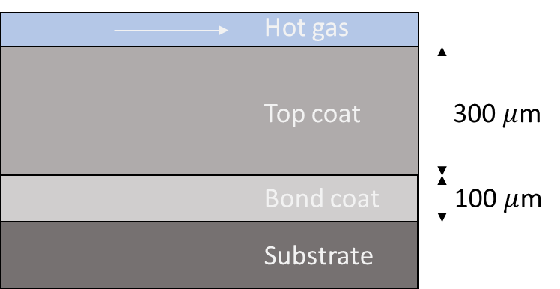
Thermal barrier coatings are built up in different layers [4]. There is at least a top coat and a bond coat attached to the substrate, as seen in Figure 1. The substrate is usually a nickel-based superalloy due to the high temperature applications. In this case, it is Hastelloy X, which has high strength and oxidation resistance up to temperatures of 1200 °C [5]. The bond coat is a 100 $μm$ thick layer that has a composition of type NiCoCrAlY, but can also be of other components such as Pt-aluminide [6]. The bond coat has the role of bonding the top coat to the substrate efficiently and adjusting the thermal expansion coefficient between the substrate and the top coat. The bond coat also provides for a thermally grown oxide layer (TGO) that will protect the substrate from corrosion in harsh environments [1].
Figure 1. Schematic of a Thermal Barrier Coating as described in section 2.1.1. The substrate is Hastelloy X, followed by the NiCoCrAlY bond coat and the top coat of Yttria-Stabilized Zirconia.

The top coat is the outmost layer of the coating and provides for the thermal insulation. The layer needs to have a combination of high toughness and low thermal conductivity to withstand the thermal cyclic fatigue which it is exposed to during use. The top coat is usually a ceramic oxide since they have the superior thermal conductivity compared to other material groups. In this case, the top coat is made of a 300 $μ$m thick layer of Yttria Stabilized Zirconia, which will be described in more detail in section 2.1.2. By controlling the pore distribution in the top coat, the properties of the layer can be maximized to provide for as good heat protection as possible for the substrate. The pores contain gas such as air, which has lower thermal conductivity then the dense material. So by introducing pores, the overall material has a lower thermal conductivity than the corresponding dense material [7].

Yttria Stabilized Zirconia

Phases of Zirconia
According to the phase diagram, which can be seen in Figure 2, pure Zirconia has three stable phases. The phases are of cubic, tetragonal and monoclinic type. Hence, the interatomic spacing differs while the numerical coordination remains the same. This allows for displacive transformations between phases to occur without bond breaking or rearrangement of the atoms. For example, the transformation to the monoclinic phase merely skews the lattice and does not change the short range order [8]. The phase transformation between tetragonal and monoclinic phase is of martensitic character and results in a volume change of about 4-7% in pure Zirconia and is taking place at about 1300 K (~1030 °C) [9] [10]. The volume change introduces stresses into the lattice, which cause problems with cracking when using pure Zirconia at high temperature applications due to the large volume changes upon the transition from the monoclinic to the tetragonal phase.

Stabilized Zirconia
There are also metastable phases that can occur due to the rapid cooling in the spray process [11]. One particularly interesting phase is a “non-transformational” tetragonal phase that is called t´ that is stable even at lower temperatures [12]. The t´-phase can be stabilized by using small amounts of stabilizer introduced into the Zirconia lattice. The choice of stabilizer can give slightly different effects on the coating regarding heat conductivity and toughness but mostly these effects have stronger correlation to the pore architecture [13]. Yttria, $Y_{2}O_{3}$, is a common material used as stabilizer. The amount of Yttria required to stabilize the t’-phase is 3-12 mole %. For 8YSZ, which is Zirconia with 8 mole% of Yttria, the decomposition of t´-phase to tetragonal and cubic phase, is hindered to temperatures as high as 1200°C [14][12]. These are phases that without stabilizer would transformed into the monoclinic phase. A phase diagram of the Yttria-Zirconia system can be seen in Figure 2.

Properties of Yttria Stabilized Zirconia
The thermal conductivity of Zirconia is $∼1.8 W/(mK)$ which combined with the relatively high fracture toughness of about $∼3-6 MPa √m$ is one of the reasons why the material is of interest in thermal barrier applications. However, the thermal properties of YSZ differ depending on the porosity of the material. This has been shown in simulations by e.g. Wang et al. [15], where YSZ has been modelled with and without pores. The pores are of more importance for lowering the thermal conductivity then the crystal structure with introduction of grain boundaries. Schlichting et al. [7] have examined single- and polycrystalline YSZ and concluded that there is no comprehensive difference regarding the thermal conductivity. Also, the toughness showed variations in dependence of grain size, and the grain size in turn is highly influenced by the amount of stabilizer. More Yttria results in bigger grains and therefore a lower fracture toughness [14].
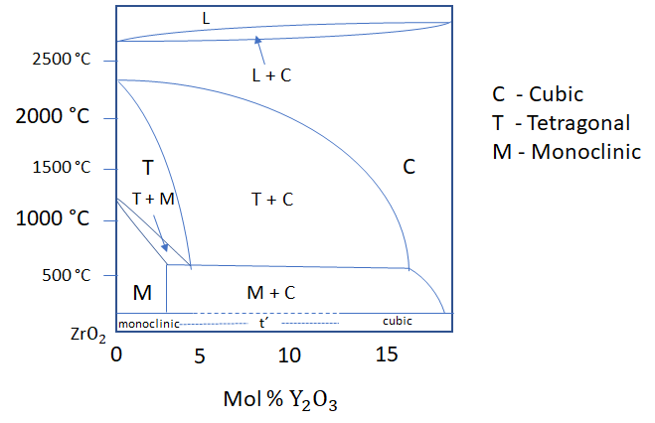
Figure 2. Phase diagram of the zirconia-rich side of the Yttria - Zirconia system as adapted from [16] . The t´-phase can be stabilized with between 3-12 mole% of Yttria as can be seen in the lower parts of the phase diagram.

Thermal spraying
Thermal spray techniques can generate coatings over a large area and at a high deposition rates with a thickness that can range from about 20 microns to several mm [17]. The general idea of thermal spraying is to spray melted particles at high velocity on to a substrate by heating a feedstock material, which usually is in form of a powder, above the melting temperature and let the particles travel in a jet stream to hit the substrate. When the droplets hit the substrate, they spread out and cool down, forming so-called “splats”. The coating is then built up by splats that are stacked on top of each other [18]. There are different thermal spray methods that are commonly used depending on the microstructural needs for the intended application.

For the bond coat, there is a need for a dense layer that has a minimum amount of impurities. In this case, High Velocity Oxy-Fuel (HVOF) technique is often used since the high velocity in which the splats form creates a dense structure. For the top coat on the other hand, the pore size distribution is of high importance since the thermal conductivity is partly determined by the porosity [2]. It is still debated on the physical reason for this, but one theory is that the main contribution to thermal conductivity at high temperature is different. Instead of phonon scattering at grain boundaries and dislocations in the material, the main reason for lowering of the thermal conductivity at high temperatures can be radiation, or movement of photons [7]. That would give the pores a more central role in defining the thermal conductivity. The top coat is usually made of a ceramic material which has a very high melting point and is of a brittle nature. Hence, the processing technique needs to produce very high temperatures to melt the material and to form the droplets and splats.

Atmospheric plasma spraying is a suitable technique for this. In plasma spraying an electric arc gun generates plasma, which is a high temperature ionized gas that reaches temperatures of 6000-15000 ˚C. The plasma is generated from an inert gas between an anode and a cathode where it is superheated. The feedstock is then fed into the plasma stream and accelerated toward the workpiece [19].

Suspension Plasma Spraying
In Suspension Plasma Spraying, the feedstock is a powder material that is suspended in a liquid instead of spraying the dry particles as they are produced. The suspension is usually ethanol, water or a mix of both. This allows for smaller particles to be used without them agglomerating too much. Agglomeration can lead to clogging of the equipment which imposes a problem. Another problem is that very fine particles are hard to direct into the jet stream. For the small-sized powder particles it is more difficult to enter into the center line trajectory of the plasma plume. Hence, they can end up in the outer parts of the plasma plume where the temperature is lower [20][21]. By using a suspension, the agglomeration can be controlled and droplets of suspension containing small particles have an easier time entering the plasma plume.

The principle of suspension plasma spraying is that the suspension breaks up into smaller droplets, i.e. the size of the droplets can be decimated. The suspension itself evaporates in the jet stream, leaving the particles free. The particles then agglomerate to smaller clusters which is followed by melting and evaporation. The melted droplets then hit the substrate and become the splats that build up the coating [20][22]. The spraying process is illustrated in Figure 3.
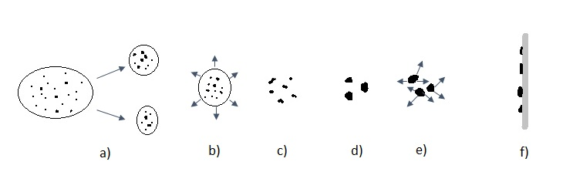
Figure 3. Illustration of the suspension plasma spraying process: a) Aerodynamic break-up of particles. b) Evaporation of solvent. c) Sintering/Agglomeration. d) Melting e) Evaporation from melt. f) Impact on substrate. Figure inspired by [20].

Formation of columnar structure in SPS coatings
As mentioned earlier, a columnar structure is of importance for the properties of the top coat. The spraying parameters will be of importance for the final microstructure of the coating by introducing porosity in a controlled manner. Areas of increased porosity act as inter-columnar spacing between columns. Since the inter-columnar spacing contains some material, it can still stop the heat from reaching the substrate [23][24]. By forming columnar structure, the coating can thermally expand without cracking.

The single splats formed of plasma sprayed YSZ are mostly circular or elliptic [25]. The smaller splats more often stick to the substrate while splats that are bigger (1 $μ$m and more) crack easily and fall off. About 30% of the splats are small, the rest (the bigger ones) could probably be agglomerates of small particles [26]. The splat formation is of great importance to understand the formation of the columnar structure in coatings.

VanEvery et al. [27] have proposed a model for the growth of SPS coatings. They suggested that depending on the size of the droplets hitting the substrate, the asperities in the substrate could be considered a breeding ground for the columnar structure of which the microstructure of the coating is built of. If the droplets are small, less than 1$μ$m, the asperities could act as shadowing structures on which the splats grow. The splats can then form dense columns as they grow. If the droplets are bigger, $∼1-5 μ$m, porosity bands can form along the sides of the growing columns. If the droplets are bigger, the splats will be evenly spread out and form a more lamellar type of coating or porosity bands that grow in different directions, making the microstructure non-columnar. Not only the droplet but also the surface roughness of the bond coat plays an important role in the growth of the microstructure by acting as the mentioned asperities [28].

Pore distribution in SPS produced TBCs
When the coating is produced with SPS, different parameters such as particle size of powder, distance from substrate and energy of the plasma plume result in different types of microstructure. The pore size distribution can range from a few nm to hundreds of microns. Also, the shape of the pores and the feather-like structure that is sought for in the top coat will be dependent on the process parameters used. The whole range of the pore sizes distribution is difficult to measure with one technique. The resolutions of different analysis techniques show great variation in pore size distribution in the same coatings [29][30]. The closed porosity cannot be reached by certain analysis techniques and this is a known problem with any technique that involves measurements with a media that penetrates the pores of the coating.

Analysis techniques
The section is an introduction to the theory behind the techniques used to characterize the pores, and the overall structure of the top coat by using NMRC and SEM.

NMRC
Nuclear Magnetic Resonance Cryoporometry is a technique that has been used mainly on organic materials since the 1990s and is making achievements regarding other areas of material science. Below is a short introduction to NMR followed by the thermodynamic properties on which cryoporometry is built upon, and the conditions needed to achieve proper results from NMRC.

Nuclear Magnetic Resonance (NMR)
In a material with non-zero nuclear spin, there is a magnetic moment. If such a material is exposed to an external magnetic field, B, the sum of the magnetic moments along the direction of the magnetic field is called the magnetization, M. If the magnetic field is non-parallel to the magnetization, the magnetization precesses about the direction of the magnetic field with an angular frequency called the Larmor frequency, $ω$.

To be able to be detected, M needs to be tilted away from the constant magnetic field, $B_{0},$ to create resonance. To achieve the tilt, a magnetic field, $B_{1}$, is produced by a low amplitude radio frequency which is perpendicular to the applied, $B_{0}$. The magnetization is described by
$$\begin{aligned}\frac{dM}{dt}=-γM×B= -M×ω, \#\end{aligned}( STYLEREF 1 \backslash s 2. SEQ Equation \backslash * ARABIC \backslash s 1 1)$$
where $γ$ is a gyromagnetic constant described as the ratio between the nuclear magnetic moment and its angular momentum. When $B_{1}$is switched off, M starts to precess around $B_{0}$ which induces a force. This is called the free induction decay (FID). By turning the RF-field on and off, different types of responses can be achieved. The FID is what is referred to as the NMR-signal [30][31].

Thermodynamic properties of pores
The thermodynamic properties of the pores are of importance in order to understand the results that are obtained by NMRC. The solid/liquid phase transition in a pore is dependent on the Helmholtz free energy for determining the equilibrium temperature, $T_{eq}$. In an arbitrary shaped pore of volume V, and surface area S, that is filled with a liquid, the Helmholtz free energy is given by:
$$\begin{aligned}F_{m}=\frac{μ_{l}V}{ν_{l}}+γ_{lw}S,\# \end{aligned}( STYLEREF 1 \backslash s 2. SEQ Equation \backslash * ARABIC \backslash s 1 2)$$
where $μ_{l}$is the bulk chemical potential, V the volume or the pore, $ν_{l}$ the molar volume of liquid, $γ_{lw}$ the surface energy of the liquid/pore wall interface, and $S$ is the surface area of the pore [33]. In the frozen solid state there is a non-freezing or pre-molten layer present next to the pore wall that affects the NMR signals and makes the volume of the crystalline material somewhat smaller than the actual pore [34]. This means that the first term of the free energy in the solid is dependent on the difference in pore volume and the volume of the solid, and the second term is extended to terms including interfacial energy of the solid/liquid and liquid/wall.
$$\begin{aligned}F_{f}= \frac{μ_{s}V_{s}}{ν_{s}}+\frac{μ_{l}\left(V-V_{s}\right)}{ν_{l}}+γ_{lw}S+γ_{sl}S_{s}\# (\end{aligned} STYLEREF 1 \backslash s 2. SEQ Equation \backslash * ARABIC \backslash s 1 3)$$
In NMRC context, this non-freezing or pre-molten layer is denoted $τ$.
The chemical potential can be expressed as $μ_{s}-μ_{l}=ΔH(T-T^{0})/T^{0}$ so that equations $2.2$ and $2.3$ can be written as the following relation:
$$\begin{aligned}ΔF≡ F_{f}-F_{m}=\frac{ΔH\left(T-T^{0}\right)}{T^{0}}\frac{V_{s}}{V_{l}}+γ_{sl}S_{s}\# \end{aligned}( STYLEREF 1 \backslash s 2. SEQ Equation \backslash * ARABIC \backslash s 1 4)$$
In the transition, $T=T_{eq}$ and $ΔF=0$, this means that the final state of the equation is highly dependent on the surface area, $S_{s}$. This is of importance for the difference in transition temperature, $T^{0}$, in bulk transitions, compared to transition temperature $T_{eq}$ in materials that are confined, like for instance in a pore. When the non-freezing layer, $τ,$ is small compared to the solid, equation $2.4$ can be simplified to:
$$\begin{aligned}ΔT=T_{eq}-T^{0}= -K\frac{dV}{dS}\# \end{aligned}( STYLEREF 1 \backslash s 2. SEQ Equation \backslash * ARABIC \backslash s 1 5)$$
Where $K$ is a constant depending on the used pore filling material. This is described later in section 2.3.1.5.

Cryoporometry
Nuclear Magnetic Resonance Cryoporometry is based on the depression of the freezing temperature when freezing and melting crystals of different sizes. This is described by the Gibbs-Thomson-equation,

$$\begin{aligned}ΔT_{m}=T_{m}^{∞}-T_{m}\left(x\right)= -\frac{4γ_{sl}T_{m}^{∞}}{xΔH_{f}ρ_{s}}cos\left(ϕ\right),\end{aligned}( STYLEREF 1 \backslash s 2. SEQ Equation \backslash * ARABIC \backslash s 1 6)$$
where $T_{m}^{∞}$ is the melting temperature of the bulk solid, $T_{m}(x)$ is the melting temperature of a crystal of diameter $x$, $γ_{sl}$is the surface energy of the solid/liquid interface. $ΔH_{f}$is the bulk enthalpy of fusion, $ρ_{s}$ is the density of the solid, and $cos(ϕ)$ is the wetting angle term of the solid/liquid interface.

In the NMRC context, this expression is often shortened to,

$$\begin{aligned}ΔT_{m}=\frac{k_{GT}}{x}=\frac{k_{g}k_{s}k_{i}}{x},\# \end{aligned}( STYLEREF 1 \backslash s 2. SEQ Equation \backslash * ARABIC \backslash s 1 7)$$
Where $K_{GT}$ is a calibration constant that in the case of an arbitrary shape of the solid/liquid interface is expressed as $k_{GT}=k_{g}k_{s}k_{i}$. The $k_{s}$ and$k_{i}$ contains information on the solid/liquid interfacial shape, free energy and work required to separate the liquid from the pore wall. And $k_{g}$contains information on the surface-to-volume ratio of the porous matrix. $x$ is the pore size [35], which for cylindrical pores of radius $r=x$ has been shown to work well as a model [36].

The Gibbs-Thomson equation describes how the size of a solid affects the melting point and in that way creates a hysteresis between the melting and the solidification temperature when freezing a porous specimen and then heating it in discrete steps [37]. This represents the main theory of NMR Cryoporometry.

Pore throats or bottle necks
One important consideration regarding properties of solid-liquid transitions in open pores is the concept of pore throats or bottlenecks, which can be seen in Figure 4. Freezing occurs when the liquid is cooled below the equilibrium temperature and the solidification occurs differently depending whether the pore filling material is in contact with the material outside the pore or not. If the solidification front is not hindered, freezing occurs by propagating from the pore opening to the pore interior. The freezing will then occur at $T_{f}=T_{eq}$ and no metastable phases occurs. If there is hindering of the solidification front propagation by bottlenecks or pore throats where the entrance of a pore is closed, the liquid inside the pore is trapped in a metastable state of undercooling until a critical temperature, $T_{f}^{c}$, is reached [33].
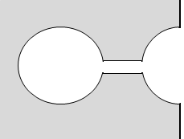
Solidification front
Figure 4. Illustration of a pore throat/bottle neck. The freezing and melting behavior of liquid confined in a pore connected with the bulk liquid and where the solidification front is hindered by a pore throat are of different nature.

Hindering can occur for example by the pore throat freezing before the solidification front enters the pore, shutting the entrance of the pore. This way the metastable liquid inside will freeze only when nucleation occurs inside the pore. The size of the pore is of importance for the phenomenon and supercooling is expected to affect small pores less then big ones. Melting of the pore content is on the other hand nucleated by the pre-molten layer at the pore surface and propagates inwards toward the center of the pore. The melting occurs at $T>T_{eq}$ when the free energy changes according to a specific surface to volume ratio [33][35].

Pore filling material
The pore filling material is the actual material that will be measured by the NMRC-technique. It is used to fill the pores in the test subject, and by freezing the sample with the pore filling material, the difference in freezing/melting range can be measured. The pore filling material, or probe liquid used, determines the results of the analysis and must be chosen depending on expected outcome. The higher the K-value of the pore-filling material, the more efficient it is. The higher K-value is necessary to get a higher upper limit of detectable pore sizes. That is, the higher$ΔT$, $ΔT_{m}$ and $r$[38]. K is also dependent on the specific volume, $v_{l}$, the interfacial energy$, γ_{sl}$, the temperature, $t_{0},$ and the latent heat of melting. The Gibbs-Thomson relation in equation $2.7$ is expressed
$$\begin{aligned}ΔT= -xK\frac{1}{r},\# \end{aligned}( STYLEREF 1 \backslash s 2. SEQ Equation \backslash * ARABIC \backslash s 1 8)$$
where$x$ is a factor depending on the shape of the pore (3, 2 or 1 for sphere, cylinder and slit, respectively). K is represented by

$$\begin{aligned}K=\frac{v_{l}γ_{sl }ΔT}{ΔH }. \# \end{aligned}( STYLEREF 1 \backslash s 2. SEQ Equation \backslash * ARABIC \backslash s 1 9)$$
The sizes of the molecules in the probe liquid and the wetting is important to fill the pores sufficiently. The smaller the molecules that are used as pore filling material, the smaller the pores that can be detected. That means by using a small molecule, the pore size that can be detected is smaller in comparison to more complex molecules such as octamethylcyclotetrasiloxane (OMCTS or $D_{4}$) which is commonly used as pore filling material in NMRC [38]. The probe liquid also needs to have a high tendency to crystallize even in small pores. The higher the crystallinity, the bigger is the difference between solid and liquid state and the NMR signals are more distinctly separated [33].

Water as probe liquid
Water has a moderate or even low K-value of 25 $nm K$, but the small size of the molecule is preferable for detection of smaller pores. The non-freezing layer of water is estimated as two layers of molecules, and in water that makes $τ=0.6 nm$.

SEM
Scanning Electron Microscopy (SEM) offers many types of techniques to be used depending on the results required. The electrons from the incident electron beam interact in different ways with the sample atoms. The backscattered electrons (BSE) and secondary electron (SE) detectors in the SEM can be used to perform imaging. The BSE interactions in the material take place deep down in the material and provide chemical or atomic number contrast. The heavier atoms have more of weakly bound electrons which can be released when hit by the electron beam. SEs are generated closer to the surface of the material and can provide topographical contrast. SEM requires the investigated sample to be conductive to lead away electrons, otherwise the imaging suffers from charging effects [39].

Methodology

Spraying
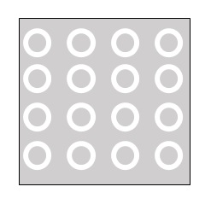
The thermal spray coatings were produced by Stefan Björklund at University West. The substrate is Hastelloy X, the bond coat is a MCrAlY-metal and the top coat an YSZ-ceramic. The bond coat was sprayed with a Uniquecoat M3 Supersonic HVAF Spray Gun and for the top coat a Mettech Axial III Suspension Plasma Spray system with a Mettech Nanofeed 350 to insert the suspension was used. The original samples came in six pieces of 25x25 mm square plates. The substrate is $1$mm thick, the bond coat is $∼100 μ$m and the top coat $∼300 μ$m thick, respectively.
Figure 5. A model of how the samples were cut with waterjet cutting.

Heat treatment
The samples were divided into two groups. One that was to remain as-sprayed and one that was heat-treated to simulate the high-temperature behavior of the material in a turbine application. The samples were heat-treated at 1150 °C for three hours in air. Earlier studies have confirmed changes in porosity in similar heat-treatments for 50 and 200h [39][40]. Discussions with researchers at University West whether if the change may appear earlier have been made, which have led to the current heat-treatment.

Sample preparations
To be able to analyse the coating using NMRC and SEM, sample preparation was done in the following way:

NMRC
To achieve good results, the material needs to be densely packed in the NMR-tube. This way the FID/NMR-signal from the bulk liquid will show less intensity compared to the signal from the actual pores so that the measurement will be less approximate. That is, to get a signal-to-noise ratio in the NMR measurement that is distinct. To improve the results from the NMRC, the samples need to be prepared in a precise manner. Since the actual measurement is carried out on the probe liquid and not on the coating material itself, the noise in the signal comes from over-excessive amounts of probe liquid in the sample. That results in the intensity of the bulk liquid signal being too high in comparison with the liquid penetrated into the pores.

The NMR-tubes have an inner diameter of 4 mm. Therefore, the samples were cut into 4 mm diameter disks using waterjet cutting to get as precise diameter and fine edges as possible to fill out the tube. An example of how the samples were cut is seen in Figure 5. After the cutting, the circular disks were still attached to the sample/plate by small bridges. They needed to be cut away and rasped to get smooth edges where they had been attached. The top coat was then removed from the substrate by submerging the sample in an aqua-regia solution. This dissolved the bond coat and released the top coat from the substrate. The bond coat of the as-sprayed samples was dissolved after 2 hours in aqua-regia solution while the heat-treated samples needed up to 6 hours for the dissolution of the bond coat. When the disks of YSZ material were taken out of the aqua-regia solution, they were cleaned with water and dried in a furnace for 2 hours at 200˚C to remove all excess fluids that could interfere with the cryoporometry measurements.
The NMR tubes and caps were weighed before the YSZ disks were gently pressed down to the bottom of the tube by using a small wooden stick. Each tube was filled so that the disks fill about 5 mm in height at the bottom of the tube.
Afterwards, the samples were weighed ones again and there was a small amount of extra purified water (milliQ) pipetted in to the tube, enough to cover the disks but not more. This was done carefully since the amount of bulk-liquid is important to keep at an as low as possible amount to obtain good result from the later NMRC measurements. The samples were again weighed, and the caps sealed with Parafilm M so that there is no evaporation of water occurring.

The samples were then centrifuged at room temperature for 60 minutes at 5000 rpm to get the probe liquid into the pores. This step is also of much importance due to the disks being very dense. They fill up the tube very well and there is hardly any water reaching and penetrating the pores in the lowest disk otherwise.

With this, the samples were ready for the NMRC analysis.

Comments on the sample preparations.
The centrifuge at the Department of Chemistry and Chemical Engineering was not able to hold the original NMR-tubes of $178$mm length, which meant that the first NMR-measurements were carried out on samples that were not centrifuged. The sample preparation needed to be re-done in tubes that fitted the centrifuge available. Without the centrifugation there was a lot of air left in-between the disks in the NMR vial and the results from the NMRC were affected. This meant that NMRC sample preparation had to be re-done by cutting the tubes at about 1,5 cm and drying them to remove the disks of material out of the vial. After drying and weighing of the sample material, the smaller tubes were put in the centrifuge. During this handling some of the heat-treated disks were too brittle and broke. For sample 2 there was enough material to fill the tube anyway, but for sample 4, some of the material broke off and the shape and edges of the disks were not as good anymore.

As there was the intention to directly compare with previous measurements, the same sample material was used. However, the amount of material was limited. This made all the steps more important since there were not many trials possible to fine tune the processes.
There were some problems with cutting the samples with waterjet cutting since the small diameter of 4 mm put the skills of the operator to the test. There were discussions whether it is possible at all to produce disks fitting the NMR-tubes, but the results were convincing after some trials.

The actual jet of water that cuts the material has a width of about $1$ mm, making each circular cut from the material $4+1+1=6$mm in diameter. Since the remaining material was to be used for SEM imaging the waste needed to be as little as possible. The initial rectangular plate ultimately fitted 4x4 disks. This would have made the maximum number of plates to use in the NMRC to be 48 of each type, as-sprayed and heat-treated. Knowing the thickness of the top coat to be $300 μ$m that would have made a little more than 14 mm in stacked material in the NMRC-tubes. Since every tube where to be filled about 5 mm this would be enough for at least two good samples for each type of material. The number of disks were however reduced at each step of the process.

After the heat treatment the samples turned white and very brittle. The brittleness made the handling of the samples after the heat treatment much more difficult. This was challenging both when snipping the disks off the grid of the substrate, since the coating sometimes fell off when the load from the nippers where applied but especially when the coating had been extracted from the substrate in aqua-regia. The white color is not something that has been investigated but the sintering of the material makes the material denser. As mentioned earlier, the porosity is of importance both for the heat conductivity and the toughness of the coating so when the sintering occurs during the heat treatment, the brittleness is an expected outcome.

SEM
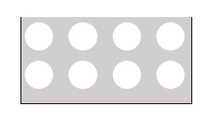
Samples for SEM analysis were prepared from the plate from which the NMRC-sample were cut from. The pieces in-between the holes were prepared, see Figure 6. First, they were cut with a diamond blade cutter. They were then mounted in PolyFast conductive polymer and grinded to get a flat surface. Afterwards, the samples were polished in four steps following Struers recommendations, beginning with a 200 $μm$ polishing, then a MD Largo polishing followed by a $3 μ$m MD-Dac polishing and last a $1μ$m MD-Nap polish. After the polishing steps, the samples were sputtered with gold to produce a conductive layer for the investigation in the SEM.
Figure 6. The part of sample used for SEM imaging.

NMRC analysis
NMRC analysis was carried out at the Swedish NMR-center using a Bruker 600 UltraShield NMR Spectrometer. The measurements were performed with help of Associate Professor Lars Nordstierna, Department of Applied Surface Chemistry, Chalmers.

NMRC procedure
Prior to putting them in the NMR-magnet, the samples were cooled in a freezer. In the magnet there is a gas stream that is set to the desired temperature, $T_{in}$.
The actual temperature in the NMR magnet was calibrated to get correct data regarding the temperature, $T_{in}$, and the intensity integral of the NMR-signal, $I_{out}$. Also, the absolute melting temperature, $T_{m}$, in the probe liquid was calibrated. When the temperatures were calibrated the sample was inserted.

The measurement starts at a temperature bellow the melting temperature of the probe liquid where all the liquid is solidified. The temperature is then increased in discrete steps. Every step is held for a time that is decided from the calibration run. At every step the temperature is set, and the NMR signal is recorded. Just below $T_{m},$ the temperature is lowered again in discrete steps. By avoiding the melting temperature, the bulk will never start to melt. That way the measuring is limited to the actual pores and the noise signal from the bulk liquid is held at a minimum. This procedure gives temperature vs signal data that is stepwise first melting and then freezing.

This follows the relationship described in the Gibbs-Thomson equation where small pores solidify at lower temperatures than large ones due to the higher surface energy and pore volume ratio of the smaller pores.

Modelling of the NMRC data
The general interpretation should be that $ΔT$ is the difference in the calibrated equilibrium temperature of the pore liquid at every discrete step, $T_{i}$, and the calibrated equilibrium temperature where the bulk liquid melts, $T_{m}$ .

$$ΔT_{m}=T_{i}-T_{m}$$

The volume is calculated from the integral of the intensity of the signal. Which means that the higher the intensity, the bigger peak of the volume. The volume is calculated as follows:
$$\begin{aligned}V_{im}=\left(I_{i,m}-I_{\left(i-1\right)m}\right){\left(\frac{r_{i,m}}{{r(}_{i,m}-τ)}\right)}^{x} \end{aligned}( STYLEREF 1 \backslash s 3. SEQ Equation \backslash * ARABIC \backslash s 1 1)$$

$$\begin{aligned}V_{if}=\left(I_{\left(i-1\right)f}-I_{i,f}\right){\left(\frac{r_{i,f}}{{r(}_{i,f}-τ)}\right)}^{x} \end{aligned}( STYLEREF 1 \backslash s 3. SEQ Equation \backslash * ARABIC \backslash s 1 2)$$
Where $I_{i}$ is the i-th temperature step regarding the Intensity, $r_{i}$ is the pore size radius calculated from equation nr $2.8$, $τ$ is the non-freezing layer of the water, and $x$ is the geometry from equation nr $2.8$. When using water, $τ=0.6 nm$ and $K=25$. [42]

The pore radius is calculated by using the assumed geometry factor x, and the known properties of the probe liquid and use them in equation $2.8)$.
$$\begin{aligned}r_{m}=-\frac{\left(x-1\right)K}{T_{m}}+τ \# \end{aligned}( STYLEREF 1 \backslash s 3. SEQ Equation \backslash * ARABIC \backslash s 1 3)$$
$$\begin{aligned}r_{f}=-\frac{xK}{T_{f}}+τ\end{aligned}( STYLEREF 1 \backslash s 3. SEQ Equation \backslash * ARABIC \backslash s 1 4)$$
To get an x-value, which is the factor representing pore geometry, the freezing curve is interpolated to match the specific values of the melting curve. The x-value, or the width of the hysteresis, is then calculated. This is shown in Figure 7.
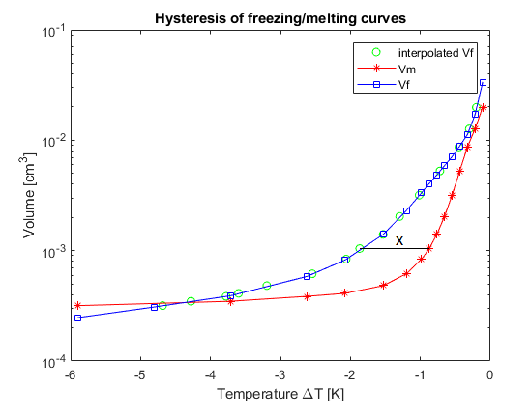
Figure 7. Evaluation of the NMRC data: By interpolating the freezing curve, the geometry factor, x, can be calculated from the width of the hysteresis.

The pore size distribution (PSD) is of importance for being able to determine/design in a certain thermal conductivity. To be able to measure small pores down to a few nm, was the main reason for using water as a probe liquid. The PSD is calculated by using the difference in volume and pore radius.
$\begin{aligned}PSD= \frac{ΔV}{Δr}\# \end{aligned}( STYLEREF 1 \backslash s 3. SEQ Equation \backslash * ARABIC \backslash s 1 5)$
When calculating the pore size distribution, only the melting curves are used. This is due to the concept of bottle necks or pore throats that is described in section 2.3.1.4. The melting can be considered to be more even regarding irregular shapes of the pores. So, the PSD in this case is a function of the difference in $V_{m}$and $r_{m}$.

SEM
The SEM used for the investigations is a Leo Gemini 1550 with a field emission gun. The detectors used are InLens and SE2 which are of SE-type. The SEM provides for images to investigate the actual coating. These can be used to understand how the bigger pores are distributed and by that describe the structure of the coating. The reader should notice that the nanometre range pores that can be detected by NMRC are not visible in the SEM pictures since the resolution of the SEM is limited.

Results
The results from the NMRC measurements showed a good signal-to-noise ratio which is shown in the specific curves in section 4.1.2. This allowed for the pore size distribution and the pore geometry to be calculated and compared between as-sprayed and heat-treated material.

NMRC
Earlier studies by Ekberg et al. [43] have shown that NMRC is a suitable technique for determining the pore size distribution and the pore geometries, but sample preparation had to be refined to lower the ratio of probe liquid to material. This could be achieved by preparing the material in a way that allows for dense packing in the NMR-tubes. This gave better results from the NMRC technique since the material/probe liquid ratio was more balanced and by that reduced the signal-to-noise ratio. More elaboration on the sample preparation can be found in the discussion.

The pore morphology in the samples can be measured by comparing the hysteresis from melting and freezing curve from the NMR signal, or the FID. When freezing the samples, there are different ratios of the solid/liquid at a specific temperature as when the sample is melted. The difference in $T_{m}$ and $T_{f}$ results in a hysteresis curve [35]. The hysteresis is a direct application of the Gibbs-Thomson relation and is determined from the intensity of the signal in the probe liquid. In this way the intensity can both show the pore size and the geometry of the pores. The results from the hysteresis can be seen in section 4.1.2.

Depending on the pore size in the coating, the width of the hysteresis, $T_{f}-T_{m}$, can be seen and used to model different types of relations as described by the methodology. The different curvatures of the pores make the shape of the hysteresis curve have different forms. The shape and width of the hysteresis curve can be shifted somewhat depending on the geometry or the presence of pore throats. The results regarding pores size and geometry can be found in sections 4.1.3 and 4.1.4.

General information on the NMRC results
There were two sets of measurements carried out, first without and then with centrifuging the samples, and the samples from the first measurement showed insufficient results, probably due to air pockets in the measuring area of the sample, and water droplets being stuck on the sides of the NMR-tube. The results were inconsistent and will not be considered further.

Samples 1 and 2 were measured with good results regarding signal-to noise-ratio. To get validation of the results another set of samples (4 and 5) were run.
This means that the calibration of the absolute freezing temperature of the water is a little bit different. This is taken into consideration when calculating the results but is good to have in mind when looking at the results.

Table 1. Sample details: First try with long NMR tubes
Name | 1 | 2 | 3 | 4 | 5 | 6
As-sprayed | x |  | x |  | x
Heat-treated |  | x |  | x |  | x
Material [g] | 0,163933 | 0,102633 | 0,097433 | 0,128366 | 0,1337 | 0,183766
Water [g] | 0,0435 | 0,042766 | 0,047266 | 0,033533 | 0,051066 | 0,062866

Table 2. Sample details: Second try with short NMR tubes.
Name | 1 | 2 |  | 4 | 5
As-sprayed | x |  |  |  | x
Heat-treated |  | x |  | x
Material [g] | 0,1483 | 0,084866 |  | 0,073483 | 0,10645
Water [g] | 0,047166 | 0,036366 |  | 0,062233 | 0,03533

Samples 1,2,4 and 5 where chosen for the second try since they contained more disks that were not cracked or shipped and therefore had a better chance of showing good results.

The results should be read with the comparison context:
As-sprayed samples: 1 & 5
Heat-treated samples: 2 & 4

Hysteresis in the melting and freezing curves:
The melting and freezing curves of the samples can be seen in an overview in Figure 8. More detailed curves of each sample are shown in Figure 9 to Figure 12.
The results in Figure 8 to Figure 12 can be interpreted as the intensity of the signal versus temperature depression.
There is a hysteresis that is clear above a certain temperature difference of $ΔT∼-7$ K. At temperatures lower than that, the results are inconsistent, which is interpreted here as a threshold for the measured data. The signal is too low in comparison with the data from the bulk which can be seen at the lower temperatures where the freezing and melting curves overlap and flatten. This behavior is shown in all curves in Figure 8 to Figure 12.

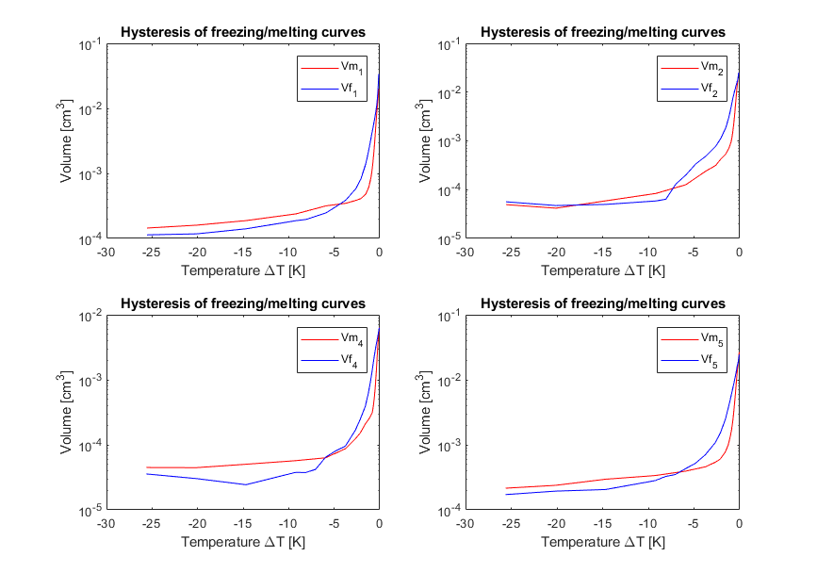
Figure 8. NMRC measurements: An overview of the hysteresis of the melting volume, $V_{m}$, and freezing volume, $V_{f}$ in the four samples 1, 2, 4 and 5. The results show that below a certain temperature difference, $ΔT∼-7$, the measurements do not show consistent results.

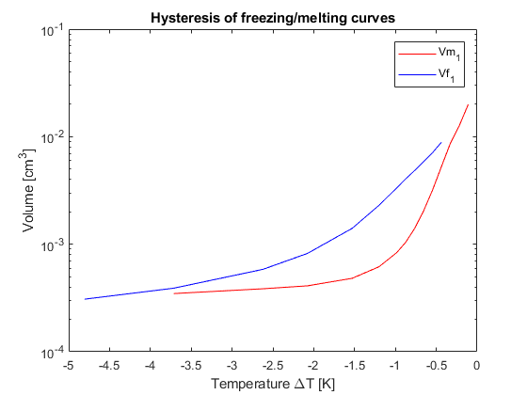
Figure 9. Hysteresis curve of Sample 1. The melting and freezing curves shows the widest hysteresis with large difference in melting and freezing temperatures.
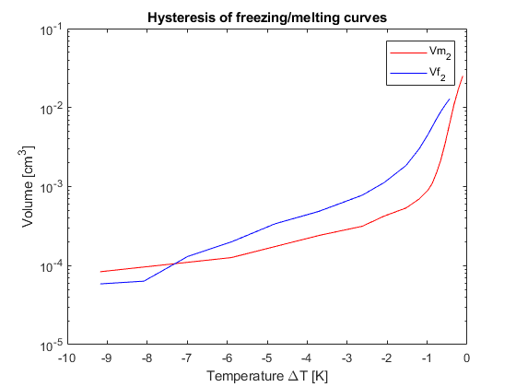
Figure 10. Hysteresis curve of sample 2. The hysteresis is not very wide but is elongated.
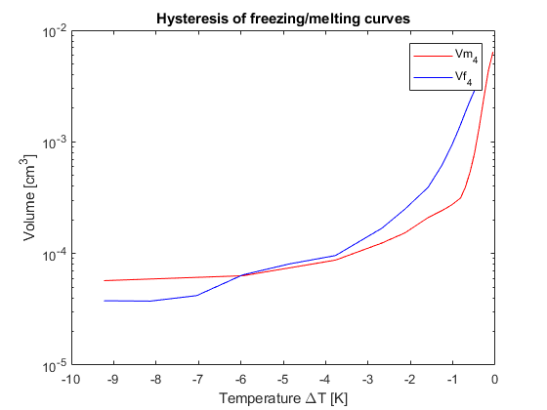
Figure 11. Hysteresis curve of sample 4. The hysteresis is narrow and the overall measured intensity is the lowest.
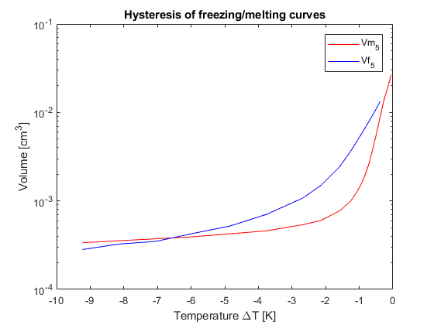
Figure 12. Hysteresis curve of sample 5. The hysteresis follows the same shape as sample 1, with a wider hysteresis showing a big difference in the freezing and melting temperatures.

The curves for as-sprayed material (1 and 5) and the heat-treated material (2 and 4) show different appearances. This suggests that the method can be used to determine what kind of general shape the pores in the material possess. According to equation Equation $2.5$, the higher the curvature of a pore is, the bigger difference in the hysteresis can be seen. The shape of the curves suggests that there might be pore throats or bottlenecks present in the as-sprayed samples, i.e. in samples 1 and 5, which are not present to the same extent in the heat-treated samples. Samples 2 and 4 follow each other more closely. The signal of sample 4 is lower than the others, which makes the individual values not comparable.

Pore geometry
To quantify a pore size distribution, there needs to be an assumed pore shape. The pore geometry factor, x, can be calculated by using the method describe in 3.4.2. The results are shown in Figure 13 and Figure 14.
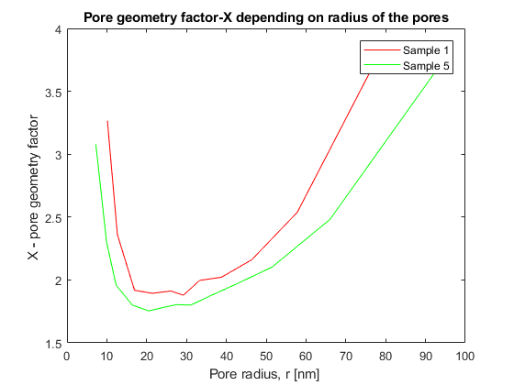
Figure 13. Calculated geometry factor x for the as-sprayed samples 1 and 5. The threshold for a change in shape is $∼$10 nm and $∼$60 nm.

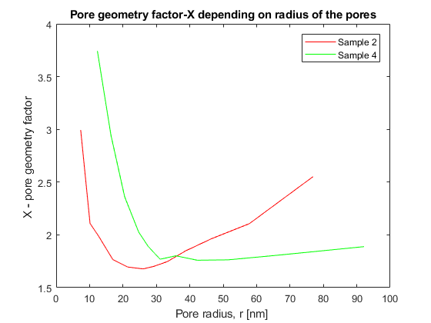
Figure 14. Calculated geometry factor x for the heat-treated samples 2 and 4. The corresponding threshold for shape change is at 8 nm and 80 nm. Sample 4 shows deviating behavior.

To make an assumption that is as accurate as possible the method described can be used. The calculated geometry factor x differs between the as-sprayed and heat-treated samples, as can be seen in Figure 13 and Figure 14. The as-sprayed samples are more prone to have circular pores at small (<10 nm) and bigger (>60 nm) radii which is represented in the x-value being closer to 3. In the heat-treated samples the small pores are also rather circular while the medium and larger sized pores are more prone to be elongated. The threshold for the transition shows a wider range of elongated pores (<8 nm and >80 nm). The information will be used when calculating the pore size distribution.

Pore size distribution
As can be seen in Figure 15 and Figure 16, the two as-sprayed samples show a very similar pore size distribution, and this shows the reproducibility of the method and that the sample preparation was successful.

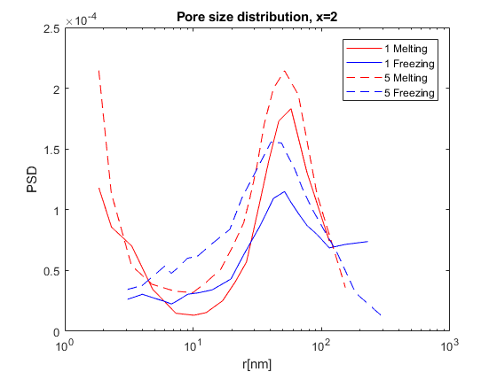
Figure 15. Pore size distribution of as-sprayed samples 1 and 5, assuming a cylindrical pore shape. There is a clear peak at about 50 nm and many pores smaller than 10 nm. Due to pore throats and bottle necks, the peaks do not show in the freezing curves.
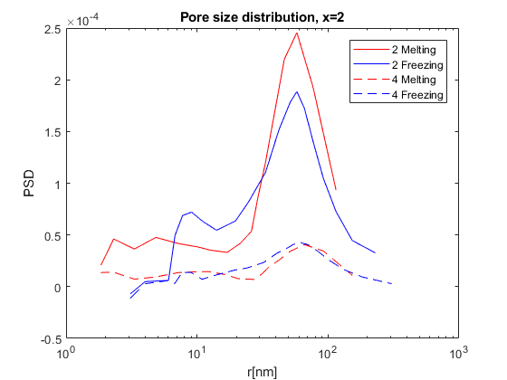
Figure 16. Pore size distribution of the heat-treated samples, 2 and 4, assuming a cylindrical pore shape. There is the peak at 50 nm but not as many pores smaller than 10 nm. Once again there are some dissimilarities in the freezing and melting curves, due to pore throats and bottle necks being present that can be seen as the peek at 8 nm.

The pore size distribution shows a great number of small pores in the as-sprayed samples but not in the heat-treated ones. This calculation of the distribution is dependent on the assumed pore geometry, as described in section 3.4.2. When changing the geometry factor, the curves have the same shape and the peaks have the same intensity but are shifted which can be seen in Figure 17a and b. This is due to the shape factor being used in Equation 3.3 and 3.4. Figure 18 shows the pores size distribution of the melting curves after corrections for pore geometry have been made. The most frequent pores seem to have a size of about 50 nm in radius in both as-sprayed and heat-treated samples.
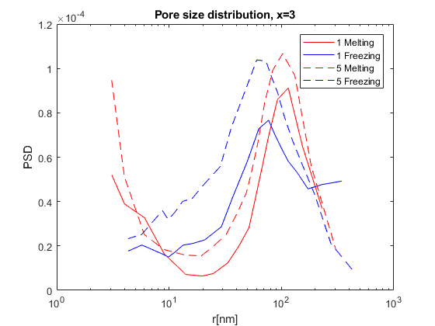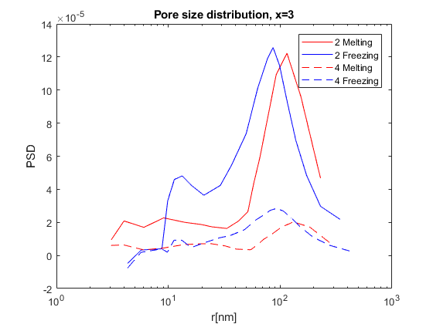
b)
a)
Figure 17. Corresponding pore size distributions in as-sprayed samples (a) and heat-treated samples (b) when the geometry is assumed to be circular. The peaks are shifted to the right and the melting and freezing data does overlap any more.

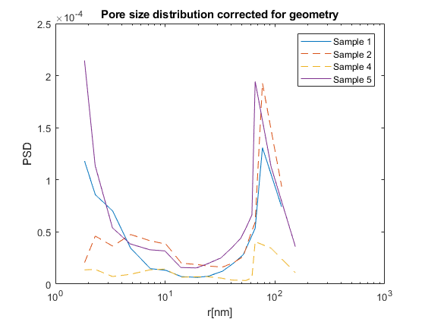
Figure 18. Pore size distribution when correction for pore geometry has been made. The as-sprayed sample 1 and 5 show a high number of small pores which is not present in the heat-treated-samples. Sample 4 has the same shape but lower intensity.

There are a lot of small pores that are less than 20 nm in diameter present in the as-sprayed samples. Pores of that size are not seen to the same extend in the heat-treated samples. The pores closed or grew together with other pores in agglomerates, which would make them increase in size, in the sintering process during heat treatment. The pore sizes that were detected range from $∼$1,5 nm to 230 nm in radius.

Porosity

Table 3. The relative pore volume of the samples.
Sample | Sample 1 | Sample 2 | Sample 4 | Sample 5
Porosity | 8% | 11% | 3% | 12%

The results in Table 3 are based on the total specific volume of confined liquid ($m^{3}/g$) in the pores measured and the density of the solid ($g/m^{3}$). One should take in consideration that the pores detected are connected pores only and that there are closed pores that cannot be reached by the pore filling material.

SEM
SEM investigations of the coatings show that a columnar structure with high amounts of big pore agglomerates forming the intercolumnar spacing are present (Figure 19). The heat-treated sample (Figure 19b) shows a denser structure with the inter-columnar spacing being more defined. The columns seem to have changed as they got a more feather-like shape as compared to the as-sprayed sample (Figure 19a). Also, a TGO layer has formed in the heat-treated sample.

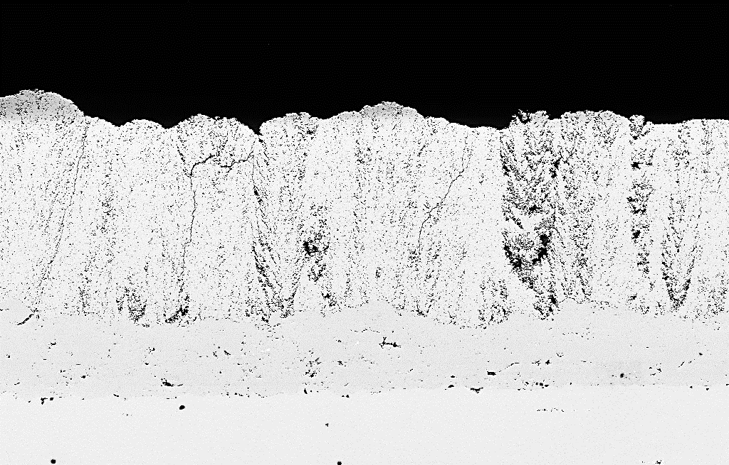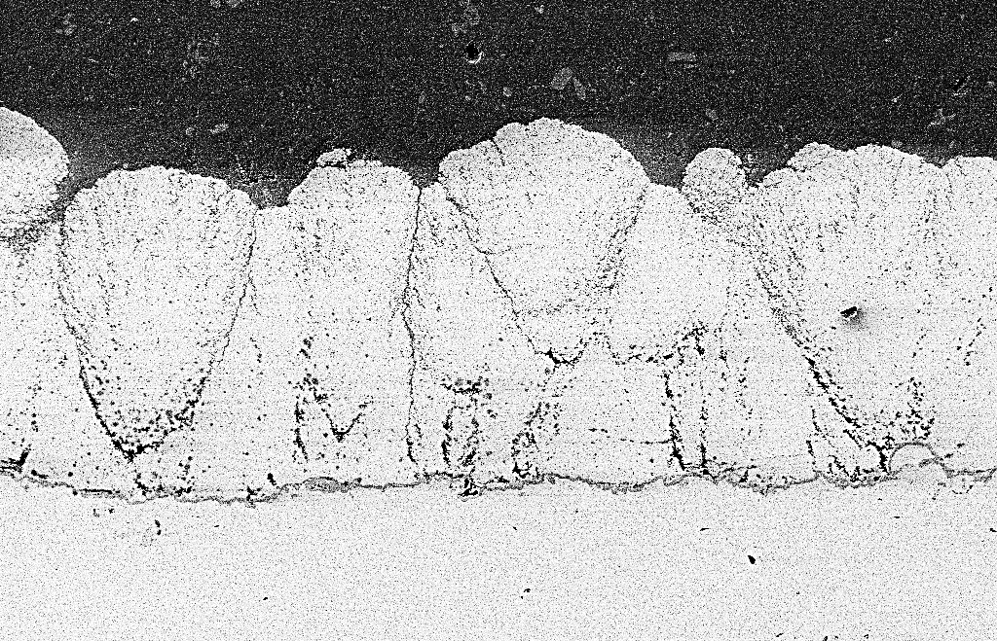
40 $μ$m
100 $μ$m
a)
b)
Figure 19. SEM images of the YSZ coating with its columnar structure in a) as-sprayed and b) heat treated condition.

As-sprayed samples
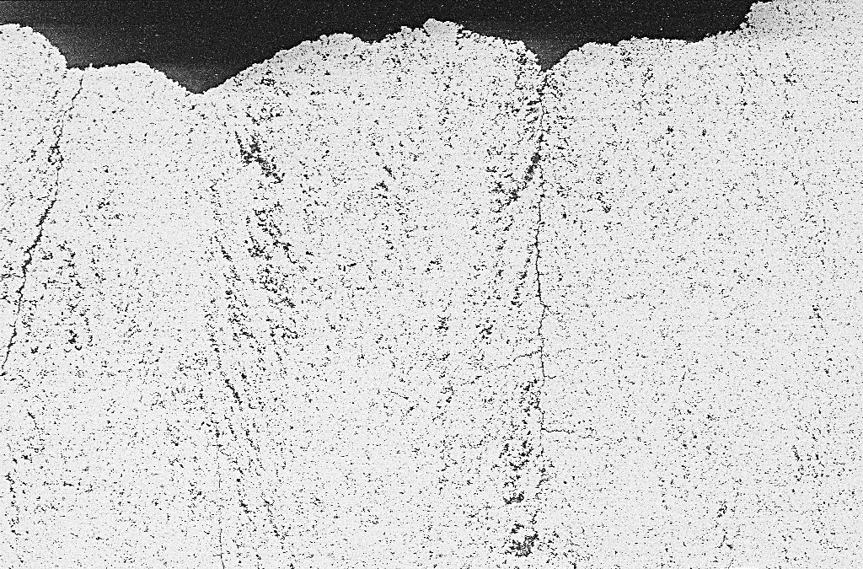
20 $μ$m
Figure 20. SEM image of as-sprayed sample. The arrows point at an inter-columnar spacing that is represented by cracks and agglomerated pores in the structure, respectively.

The as-sprayed samples have columns that are growing straight upwards. There are a wider inter-columnar spacing as mentioned and the pore agglomerates have a direction as if growing outwards and upwards from the centre of the columns. Inside the columns, the pore density seems to be more evenly distributed but there is a gradient towards the intercolumnar spacing that makes the column somewhat less porous in the middle.

There are cracks that follow the columnar structure very well. When there are a lot of pores, there are also a lot of cracks. The small pores that are in the centre of the columns are more evenly distributed. This can be seen in Figure 21. The shape of the pores is arbitrary, they are neither spherical nor cylindrical at sub-micron size and bigger, which can be detected by the SEM.
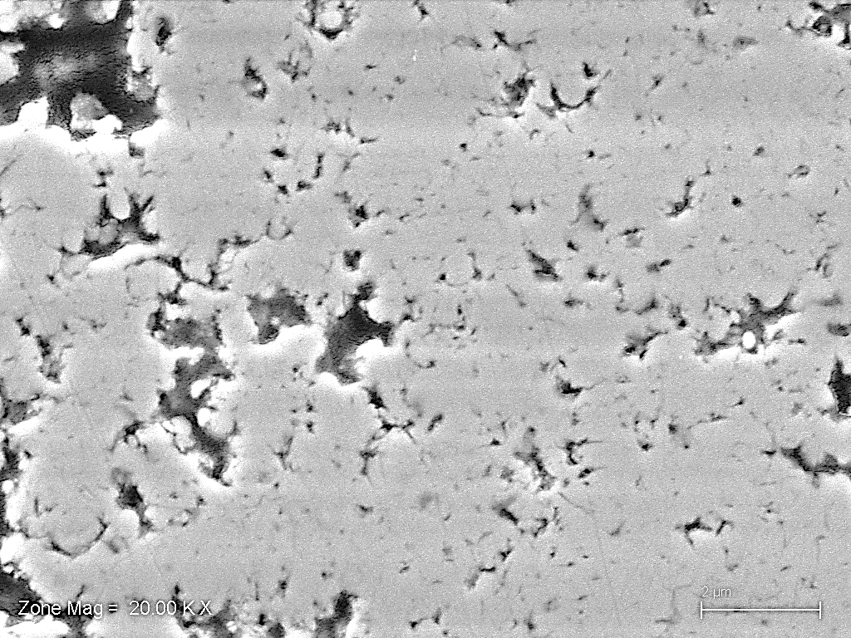
2 $μ$m
Figure 21. SEM image of an as-sprayed sample showing some of the agglomerated pores (long arrow) closer to the inter-columnar spacing at the left and smaller pores which are well distributed over the sample (short arrow).

Heat-treated samples
In the heat-treated samples, the columns are of a more feather-like pattern as mentioned. The top coat is detached from the bond coat by the TGO layer and the overall porosity has changed characteristics somewhat. There are fewer visible pores inside the columns and the inter-columnar spacing is wider. The cracks are clearly visible in the columnar spacing and have widened substantially. This can be seen in Figure 23.

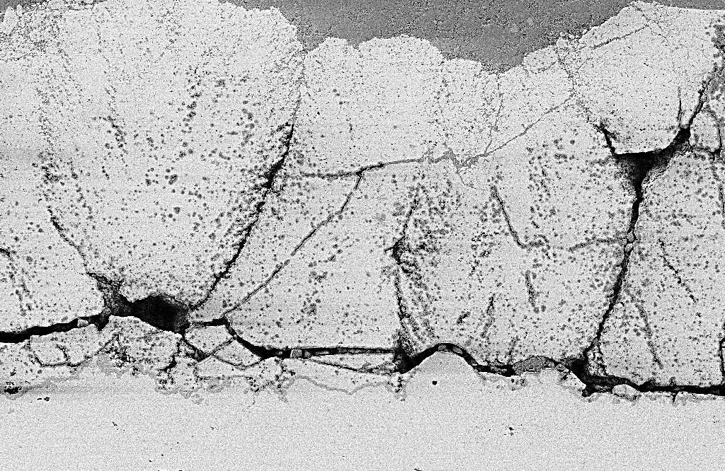
30 $μ$m
Figure 23. SEM image of the heat-treated sample. There is a TGO showing in between the top coat and the bond coat (arrow). The microstructure is denser and the inter-columnar spacing has widened.

Discussion

NMRC
The NMRC technique is supposed to work well for materials made of YSZ. Since the YSZ has a high surface energy, most inserted liquids should be able to completely wet the pores, which is of great importance with respect to NMRC measurements [43]. By using a small molecule such as water, small pores should be possible to be detected. It can however be more problematic to detect the bigger pores since they would be more prone to act as the bulk liquid due to the low K-value of water. To measure the bigger pores one can use other techniques such as MIP or image analysis. The results regarding the importance of sample preparation show that the NMRC results can be much more reliable when using the right liquid/solid ratio [22]. A perfect example of sample preparation is shown in Figure 25. Perfectly dense packing of the material is achieved and the probe liquid is pressed into the pores, leaving a layer of water so thin that it can hardly be seen.

When looking at the pore size distribution, the most frequent pores have a size of 50 nm in radius, both in as-sprayed and heat-treated samples. The as-sprayed samples also show a lot of small pores which is not the case in the heat-treated samples.

Compared to previous results by Ekberg [41][43], the present results on the pore size distribution are interesting in terms of size. The NMRC measurement by Ekberg were performed on the same material but with OMCTS as probe liquid. OMCTS is a larger molecule than water and possesses a higher K-value. The use of water as probe liquid allowed the detection of smaller pores, i.e. down to $∼$1,5 nm in radius, compared to $∼$4 nm when using OMCTS. The upper limit is also somewhat different. Ekberg et al. [43] detected pores of about 400 nm in radius while the present measurements with water provided results on pore diameters up to 230 nm, this is probably due to the mentioned K-value being much lower and the one in OMCTS. However, there are better techniques to measure large pores and the intercolumnar spacing, e.g. image analysis and MIP. The advantage of NMRC lies in the ability to measure the very small pores. The main goal here was reached since the smaller pore sizes could be detected with water then with OMCTS.

There were inconsistencies regarding the results from sample 4, which can be seen clearly from the pore size distribution in Figure 16, where the curves of sample 4 follow the same trend as sample 2, but at a much lower intensity. The lower intensity is shown also in the overview in Figure 8 and Figure 11, where the hysteresis curves are shown. The hysteresis curves follow the same trend and have the same shape as sample 2, but with an intensity that is a magnitude lower. The reasons for this could lie in the sample preparation which will be discussed more thoroughly in section 5.2. This could be treated as a bad result and there is no reproducibility of the measurements but, in fact, it shows how important the sample preparation is.

The pore geometry distribution in the as-sprayed samples shows that the threshold for the change in pore shape from circular to cylindrical is at 60 nm in pore radius. The small pores could be cracks , hence the elongated shape. At even smaller pore sizes, about 10 nm, there seems to be another threshold where the pores are more prone to be circular again, this could be due to the crack-like pores closing to the more energy- beneficial circular shape. The thresholds seem to be similar but slightly shifted in the heat-treated samples, even if samples 4 is disregarded. These tendencies are shown in section 4.1.3. This shape change at the smaller sizes does not seem to be described in the earlier studies. An interesting observation regarding the pore geometry can be made when comparing with previous research. Ekberg et. al found the pore geometry to change from elongated shape to spherical at a threshold of about 140 nm in radius [43] but the methods and models described in section 3 allows for some errors in the interpretations of the threshold.

Regarding the shape of the pores, the curves in section 4.1.3 do not show the smallest and the biggest pores. By using the modeling described in section 3.4.2, an x-value or pore geometry factor is calculated. However, a simplified model is used to describe the pores, where an enclosed sphere or circle, is represented by an x-value of 3, an elongated or cylindrical shape is represented by an x-value of 2, and an even more elongated and flattened shape, a slit, is represented by a x-value of 1. This means that values above 3 or below 1 do not have a physical representation and the somewhat simplified model does not apply. The values for the smallest pores where as high as 7, which would represent shapes that are of more topological nature, and hence not as easy to interpret by a 3D sphere or cylinder, and for the bigger pores even negative-values were calculated. The negative values are caused by the fact that the hysteresis curves are overlapping for lower temperatures since the x-values are calculated from the difference in freezing and melting temperatures.

Another method to use for shape determination is to simply assume a shape and compare the freezing and melting curves over the different pore sizes and see where the overlap fits the best. This showed similar results but they were not presented in the results section. Instead, the curves can be found in appendix B.

The results show some correlation between the pore size and pore geometry as certain pores are more prone to disappear during the heat treatment. There are thresholds where the pores seem to change shape, and there is a threshold beyond which pore sizes are not present in the heat-treated samples. These thresholds correlate well with each other. From this result it can be deduced that there are not many pores with less than 20 nm in radius in the heat treated samples and the shape of the small pores is mostly circular. The obtained pore size distribution compares also well to studies of similar coatings, where heat-treated samples show also fewer pores of smaller size [41].

The observation of pore throats or bottle necks in the as-sprayed samples but not to the same extend in the heat-treated is probably due to that pores likely close at the places where the pores are the thinnest, which in this case is the throat or bottle neck.

The porosity measurements in samples 1 and 5 and in sample 2 and 4, respectively, should have similar porosity. Keeping in mind that the porosity is only measured on the open pores, there is not a big difference from earlier studies. Earlier studies have found a good match when comparing NMRC with MIP and XRM in different size ranges [43].The ranges of pores up to 200 nm in that studie show similar values as for the work in this thesis. The porosity lies at around 8-12 % for this size range. The as-sprayed samples are supposed to have an overall porosity of about 25%, which is measured with a combination of MIP and SEM and the heat-treated samples are supposed to have a somewhat lower porosity (to follow the reasoning of smaller pores closing or forming bigger pores). This lower porosity in heat-treated samples cannot really be seen in this study since the range of total porosity of pores smaller then 200 nm is 8-12% in all samples except from sample 4.-+

SEM
There are clear effects of the heat-treatment that can be seen when using SEM. The porous columnar structure seems to have sintered and densified. The columns get a more feather-like shape which is broader at the top than at the bottom. One reason for this could be that the pores at the bottom of the top coat are agglomerated more than the ones closer to the top which are more prone to be closed in the sintering process of the heat-treatment. That needs to be validated, but one reason could be that the growth of the TGO that can be seen in Figure 23 influences the pores closer to the bottom.

There is evidence that grain growth in the material itself is not affected by the TGO [29], but how the pores are affected by the grain growth itself is not really examined and his thesis did not examine whether or not there is grain growth due to the heat-treatment. From the SEM images, it is not possible to say if there is one certain shape of pore that has disappeared. It must however be stressed that the quality of the images makes the overall interpretation of the pores somewhat difficult. Here, more detailed investigations at different magnifications would be required.

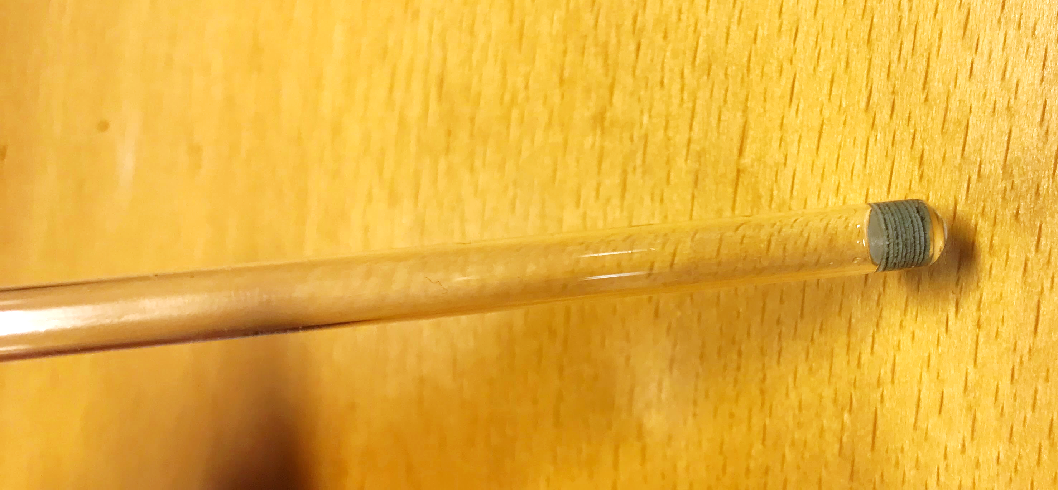

Figure 25. A perfectly prepared sample for NMRC: sample nr 5. The disks are packed very dense and fill the whole cross-sectional area of the tube. The liquid is so well pressed in to the pores that it can hardly be seen at the top of the material.

Conclusion

The results show that by using water as probe liquid in NMRC, pores as small as a few manometers can be detected. Compared to previous results using OMCTS as probe liquid, there are smaller pores detected. On the other hand, there are not as big pores detected. This could be related to different properties in probe liquids, where the higher K-value of OMCTS gives a more accurate reading at bigger pore sizes. This shows the importance of using the right probe liquid depending on which measurements are required.

Comparing results from as-sprayed and heat-treated material reveals that the smallest pores disappear when heat treated. When determining the pore shape, the description reveals that the smallest pores, (<10 nm) and the biggest pores (>60 nm) are of mostly circular shape while the medium sized pores can be best described with a cylindrical shape. When comparing the as-sprayed and the heat-treated samples, the transitions from circular to cylindrical shape appear at slightly different pore sizes (8 instead of 10 nm and 80 instead of 60 nm), but the differences are small.

To get as high as possible signal-to-noise ratio during NMRC measurements, the material must be packed densely in the NMR-tube. A few important steps were proven to be successful: Cutting the coating material in a precise manner so that the edges are sharp, and the produced disk shape is circular to fit the tube. It is also necessary to take extra care when handling the material and when detaching it from the substrate. By following these steps, the signal-to-noise ratio of the NMRC data could be improved.

Recommendations on further research
One should repeat the measurements with OMCTS or another probe liquid with a high K-value and perform the sample preparation to validate the previous results and allow for comparison with the present measurement (i.e. when using water as probe liquid).

More trials have to be done to guarantee repeatability when using this specific method for sample preparations: crucial is also the availability of sufficiently coating material due to the potential high amount of losses in the process.

This thesis could not (ultimately) answer which pores (shape and sizes) remain after sintering. Hence, further measurements are required and the model description of how to assume the shape of pores has to be refined.

Also, other techniques could be used to determine how the particles of material around the agglomerated pores are actually build up. By determining how the edges of the pores look like, one could get a better understanding of the pores real shapes since they are probably not either perfectly circular nor perfectly elliptical. This could give results regarding pore shapes that are more or less stable at higher temperatures. EBSD could be helpful since it is a technique that can determine the grain size and orientation at the edges of the pores. Also, SEM images could be more thoroughly analysed with image processing to get a statistically reliable information on shape and size of bigger pores in as-sprayed and heat-treated samples.

NMRC can also be used combined with other NMR-techniques such as NMR Relaxometry and NMR Diffusometry to get even more precise information on pore morphology due to the different nature of the techniques [44].

References

[1] W. Beele, G. Marijnissen, and A. Van Lieshout, “The evolution of thermal barrier coatings - Status and upcoming solutions for today’s key issues,” Surf. Coatings Technol., vol. 120–121, pp. 61–67, 1999.
[2] A. Ganvir, C. Kumara, M. Gupta, and P. Nylen, “Thermal Conductivity in Suspension Sprayed Thermal Barrier Coatings: Modeling and Experiments,” J. Therm. Spray Technol., vol. 26, no. 1–2, pp. 71–82, 2017.
[3] U. Klement, J. Ekberg, S. Creci, and S. T. Kelly, “Porosity measurements in suspension plasma sprayed YSZ coatings using NMR cryoporometry and X-ray microscopy,” J. Coatings Technol. Res., vol. 15, no. 4, pp. 753–757, 2018.
[4] N. Curry, “Design of Thermal Barrier Coatings,” University West, 2014.
[5] “ASM specialty handbook: nickel, cobalt, and their alloys,” Choice Rev. Online, 2013.
[6] C. G. Zhou and Y. X. Song, “Oxidation and hot corrosion of thermal barrier coatings (TBCs),” Therm. Barrier Coatings, pp. 193–214, Jan. 2011.
[7] K. W. Schlichting, N. P. Padture, and P. G. Klemens, “Thermal conductivity of dense and porous yttria-stabilized zirconia,” J. Mater. Sci., vol. 36, no. 12, pp. 3003–3010, 2001.
[8] Y.-M. Chiang, D. P. Birnie, and W. D. Kingery, Physical Ceramics. 1997.
[9] F. Cardarelli, Materials Handbook, vol. 150, no. 3798. 2018.
[10] R. C. Garvie and S. K. Chan, “Stability limits in the monoclinic-tetragonal transformations of zirconia,” Phys. B+C, vol. 150, no. 1–2, pp. 203–211, 1988.
[11] H. G. Scott, “Phase relationships in the zirconia-yttria system,” J. Mater. Sci., vol. 10, no. 9, pp. 1527–1535, 1975.
[12] X. Ren, M. Zhao, J. Feng, and W. Pan, “Phase transformation behavior in air plasma sprayed yttria stabilized zirconia coating,” J. Alloys Compd., vol. 750, pp. 189–196, 2018.
[13] S. Paul, A. Cipitria, S. A. Tsipas, and T. W. Clyne, “Sintering characteristics of plasma sprayed zirconia coatings containing different stabilisers,” Surf. Coatings Technol., vol. 203, no. 8, pp. 1069–1074, 2009.
[14] M. Trunec and Z. Chlup, “Higher fracture toughness of tetragonal zirconia ceramics through nanocrystalline structure,” Scr. Mater., vol. 61, no. 1, pp. 56–59, 2009.
[15] X. Z. Wang, X. Y. Liu, Q. Y. Chen, W. Huang, S. Pilla, and G. Y. Liang, “Understanding the effect of porosity on thermal properties of yttria-stabilized zirconia using molecular dynamics simulation,” J. Mol. Liq., vol. 222, pp. 88–93, 2016.
[16] Insaco, “The Forms and Phases of Zirconia Engieeering Ceramics that Lead to High Strength and Toughness- Insaco Inc.,” AZO Materials, 2011. .
[17] W. J. Berndt, Christopher C, Lenling, “Introduction to Thermal spray Technology and Surface Science,” Handb. Therm. Spray Technol., pp. 1–40, 2004.
[18] J. R. Davis, Handbook of Thermal Spray Technology. ASM International, 2004.
[19] P. Reference and P. Vol, “ASM handbook; v.5A; thermal spray technology.,” vol. 28, no. Oct, pp. 1–2, 2013.
[20] L. Pawlowski, “Surface & Coatings Technology Suspension and solution thermal spray coatings,” Surf. Coat. Technol., vol. 203, no. 19, pp. 2807–2829, 2009.
[21] E. Dalir; C. Moreau; A. Dolatabadi, “Three-Dimensional Modeling of Suspension Plasma Spraying with Arc Voltage Fluctuations,” J. Therm. Spray Technol., vol. 27, no. 8, pp. 1465–1490, 2018.
[22] J. Ekberg, “Investigation of microstructure and porosity of columnar yttria-stabilized zirconia coatings produced by axial suspension plasma spraying,” 2017.
[23] B. Bernard and V. Schick, “Effect of Suspension Plasma-Sprayed YSZ Columnar Microstructure and Bond Coat Surface Preparation on Thermal Barrier Coating Properties,” pp. 1025–1037, 2017.
[24] B. Bernard et al., “Thermal insulation properties of YSZ coatings: Suspension Plasma Spraying (SPS) versus Electron Beam Physical Vapor Deposition (EB-PVD) and Atmospheric Plasma Spraying (APS),” Surf. Coatings Technol., vol. 318, pp. 122–128, 2017.
[25] T. Chraska and A. H. King, “Transmission electron microscopy study of rapid solidification of plasma sprayed zirconia — part I. First splat solidification,” Thin Solid Films, vol. 397, no. 1–2, pp. 30–39, 2001.
[26] J. Ekberg, U. Klement, and S. Björklund, “Analysis of single splats produced by axial suspension plasma spraying Analysis of single splats produced by axial suspension plasma spraying,” Surf. Eng., vol. 00, no. 0, pp. 1–5, 2017.
[27] K. Vanevery et al., “Column formation in suspension plasma-sprayed coatings and resultant thermal properties,” J. Therm. Spray Technol., vol. 20, no. 4, pp. 817–828, 2011.
[28] D. Li et al., “Effect of the Bond Coating Surface Morphology on Ceramic Splat Construction,” J. Therm. Spray Technol., vol. 24, no. 8, pp. 1450–1458, 2015.
[29] U. Klement, J. Ekberg, and A. Ganvir, “EBSD Analysis and Assessment of Porosity in Thermal Barrier Coatings Produced by Axial Suspension Plasma Spraying ( ASPS ),” vol. 879, pp. 972–977, 2017.
[30] A. Ganvir et al., “Influence of Microstructure on Thermal Properties of Axial Suspension Plasma-Sprayed YSZ Thermal Barrier Coatings,” J. Therm. Spray Technol., vol. 25, no. 1–2, pp. 202–212, 2016.
[31] V. Mlynárik, “Introduction to nuclear magnetic resonance,” Anal. Biochem., vol. 529, pp. 4–9, 2017.
[32] C. Kittel, Introduction To Solid State Physics 8Th Edition. 2003.
[33] O. V. Petrov and I. Furó, “NMR cryoporometry: Principles, applications and potential,” Prog. Nucl. Magn. Reson. Spectrosc., vol. 54, no. 2, pp. 97–122, 2009.
[34] J. F. D. Liljeblad, I. Furó, and E. C. Tyrode, “The premolten layer of ice next to a hydrophilic solid surface: correlating adhesion with molecular properties,” Phys. Chem. Chem. Phys., vol. 19, no. 1, pp. 305–317, 2017.
[35] J. Mitchell, J. B. W. Webber, and J. H. Strange, “Nuclear magnetic resonance cryoporometry,” Phys. Rep., vol. 461, no. 1, pp. 1–36, 2008.
[36] C. L. Jackson and G. B. McKenna, “The melting behavior of organic materials confined in porous solids,” J. Chem. Phys., vol. 93, no. 12, pp. 9002–9011, 1990.
[37] A. Johnson, U. States, and S. Corporation, “Generalization of the gibbs-thomson,” vol. i, pp. 429–444, 1965.
[38] B. Liu, S. Yao, W. Hu, and J. Cao, “Applying octamethylcyclotetrasiloxane as a probe liquid for characterizing the pore size distribution of oil-bearing tight sandstones by nuclear magnetic resonance cryoporometry,” Mar. Pet. Geol., vol. 88, pp. 814–825, 2017.
[39] J. I. Goldstein, D. E. Newbury, J. R. Michael, N. W. M. Ritchie, J. H. J. Scott, and D. C. Joy, Microscopy and X-Ray Microanalysis. .
[40] A. Ganvir, N. Markocsan, and S. Joshi, “Influence of Isothermal Heat Treatment on Porosity and Crystallite Size in Axial Suspension Plasma Sprayed Thermal Barrier Coatings for Gas Turbine Applications,” Coatings, vol. 7, no. 1, p. 4, 2016.
[41] J. Ekberg, A. Ganvir, U. Klement, and L. Nordstierna, “The Influence of Heat Treatments on the Porosity of Suspension Plasma-Sprayed Yttria-Stabilized Zirconia Coatings,” J. Therm. Spray Technol., vol. 27, no. 3, pp. 391–401, 2018.
[42] Å. Östlund, A. Idström, C. Olsson, P. T. Larsson, and L. Nordstierna, “Modification of crystallinity and pore size distribution in coagulated cellulose films,” Cellulose, vol. 20, no. 4, pp. 1657–1667, 2013.
[43] J. Ekberg, L. Nordstierna, and U. Klement, “Porosity investigation of yttria-stabilized zirconia topcoats using NMR cryoporometry,” Surf. Coatings Technol., vol. 315, pp. 468–474, 2017.
[44] M. Krutyeva et al., “Characterization of carbon materials with the help of NMR methods,” Microporous Mesoporous Mater., vol. 120, no. 1–2, pp. 91–97, 2009.

Appendix

Spraying parameters
Spraying parameter | Coating
Suspension feed rate (ml/min) | 100
Total power during spray (kW) | 124
Surface speed (cm/s) | 216
Spray distance (mm) | 100
Total gas flow (l/min) | 300

Graphs used for determining geometry

